Class 1 October news
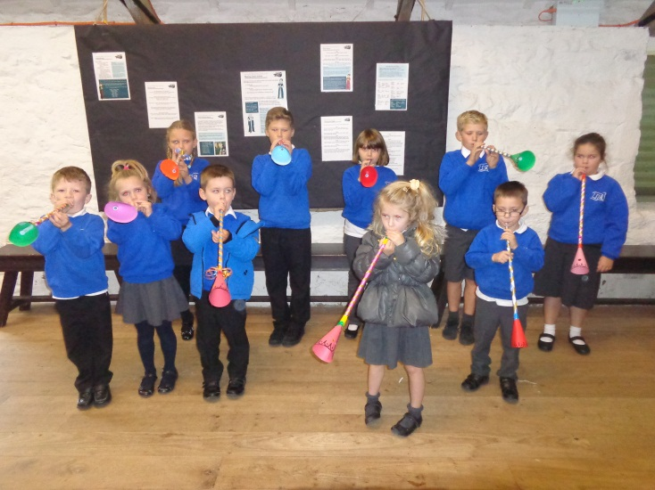
Class 1 have been learning about The Tudors in our topic lessons. We went on a trip to Trerice, to learn about how the Tudors would have lived. We made a musical instrument called a shawm. We also got to dress up in Tudor costumes. We played some of the games which Tudor children would have enjoyed.
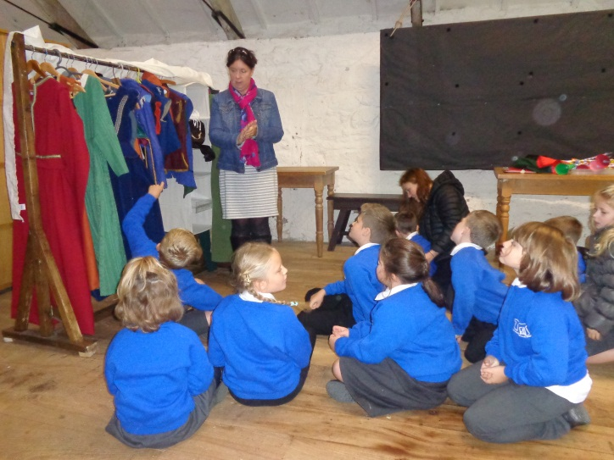

We also had a go at making some Tudor soup, called pottage. We peeled and chopped lots of vegetables and added oats to thicken it up. We didn’t ike it very much!

Class 1 have been learning about different shapes, and how to describe shapes using mathematical language. We have been on shape hunts around the school.
