**Class 2 - December News 2016**

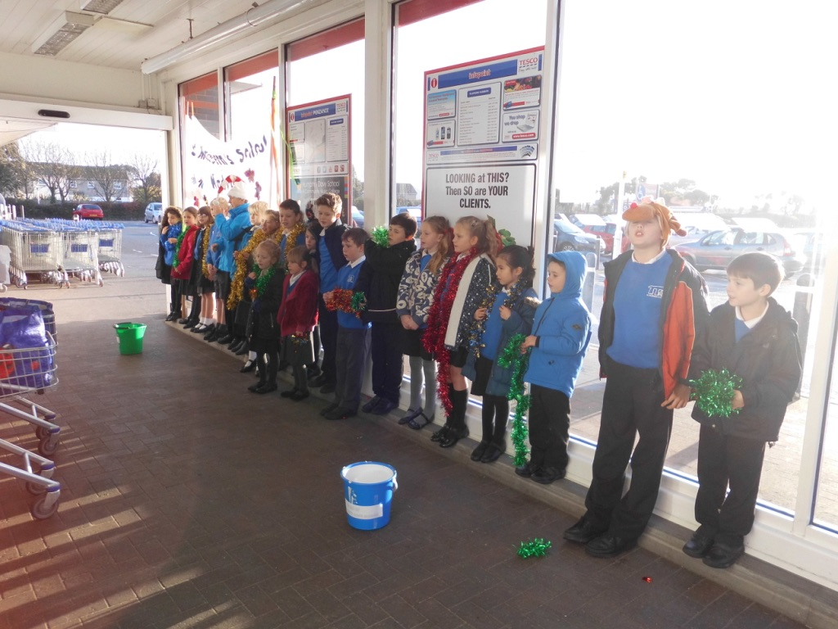Class 2 have been very busy this month getting in the festive spirit by doing lots of singing! We have visited nursing homes to sing Christmas songs to the elderly, and Tesco’s to sing to the public.

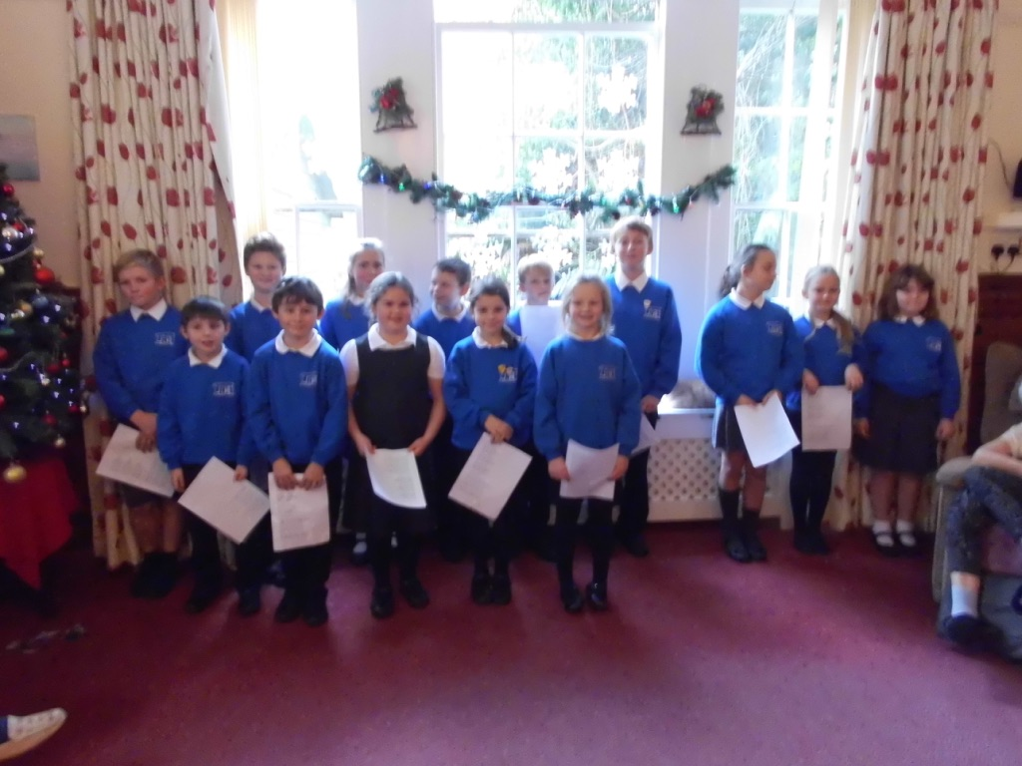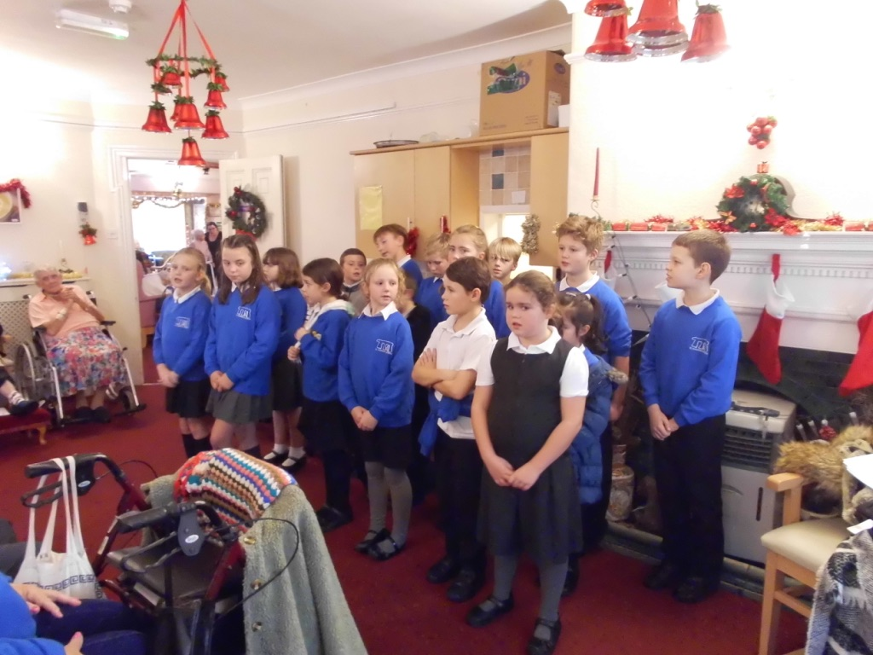

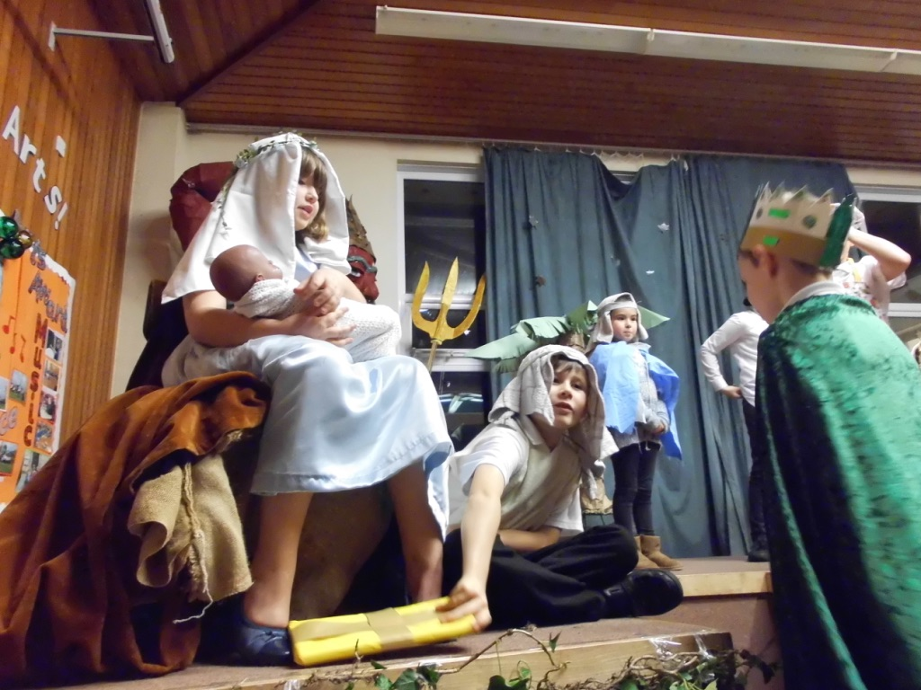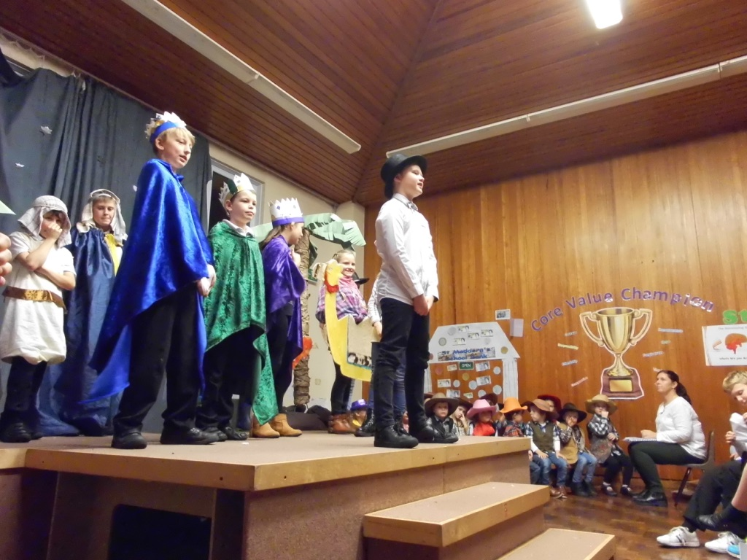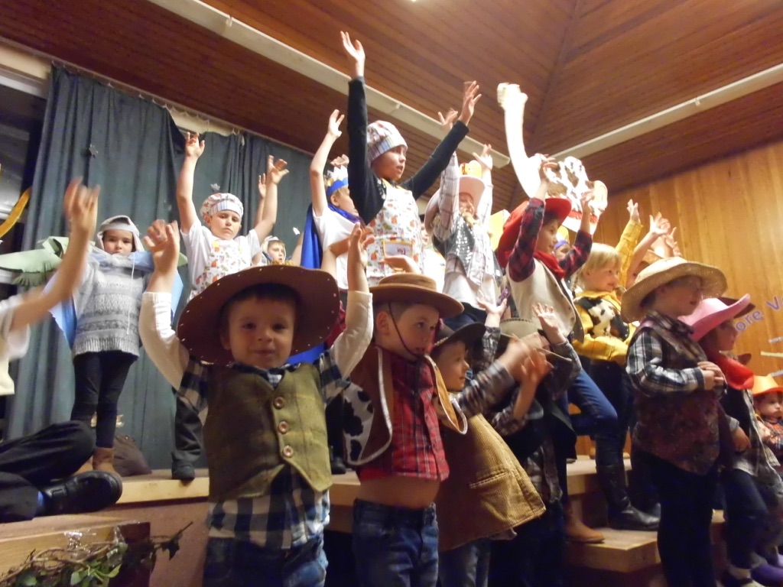  
  
We have also been busy preparing for our Christmas Nativity play along with Class 1. Here are some pictures from us on the night!

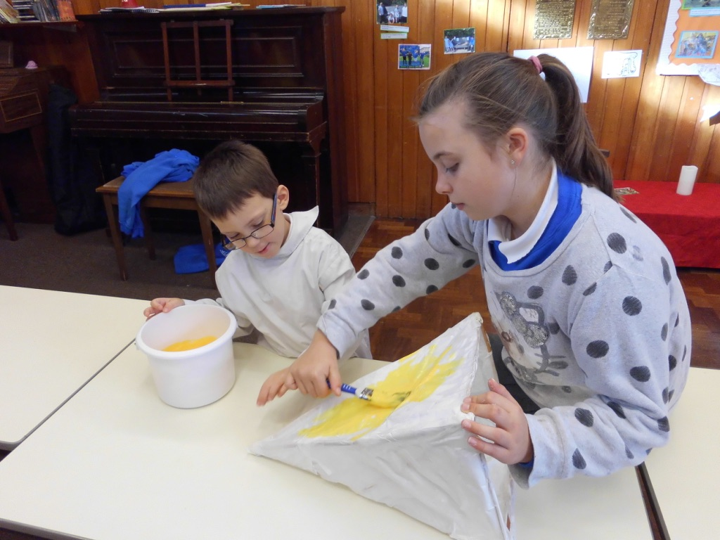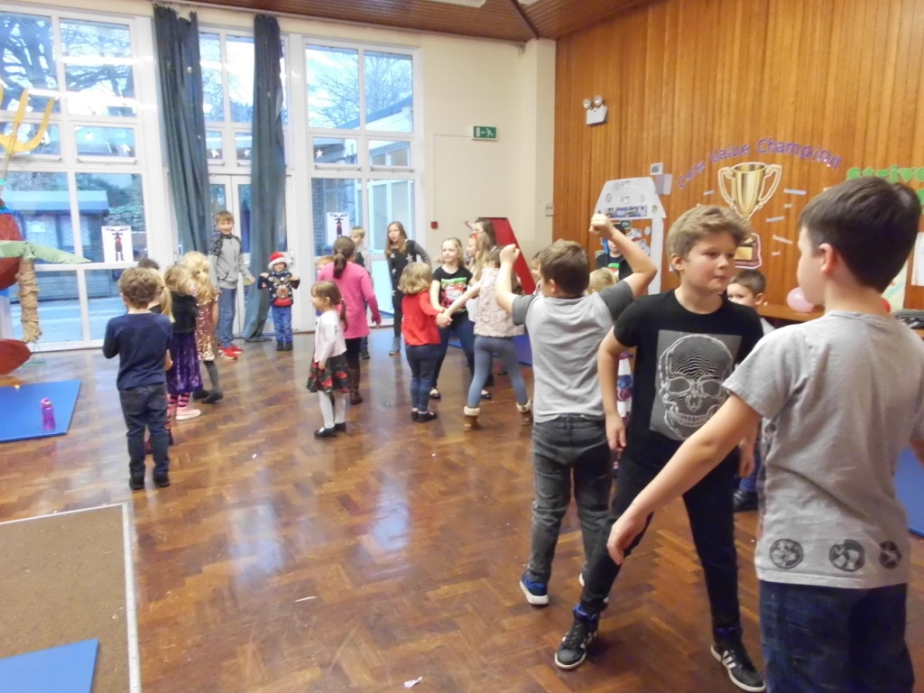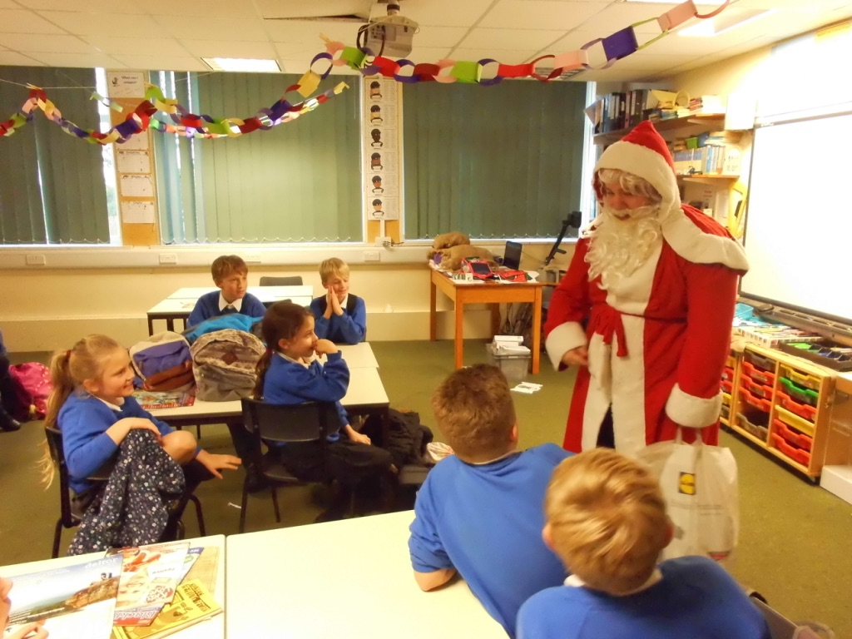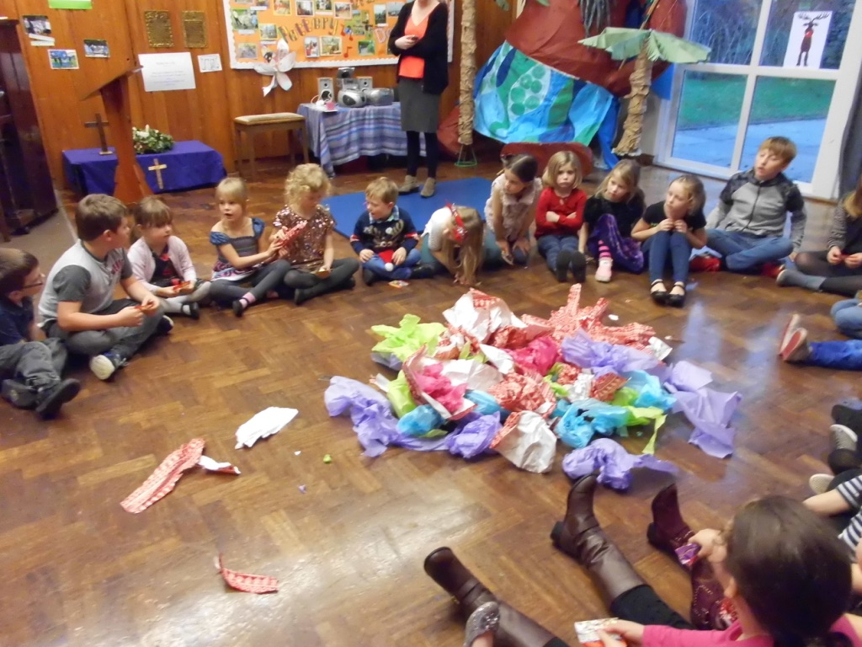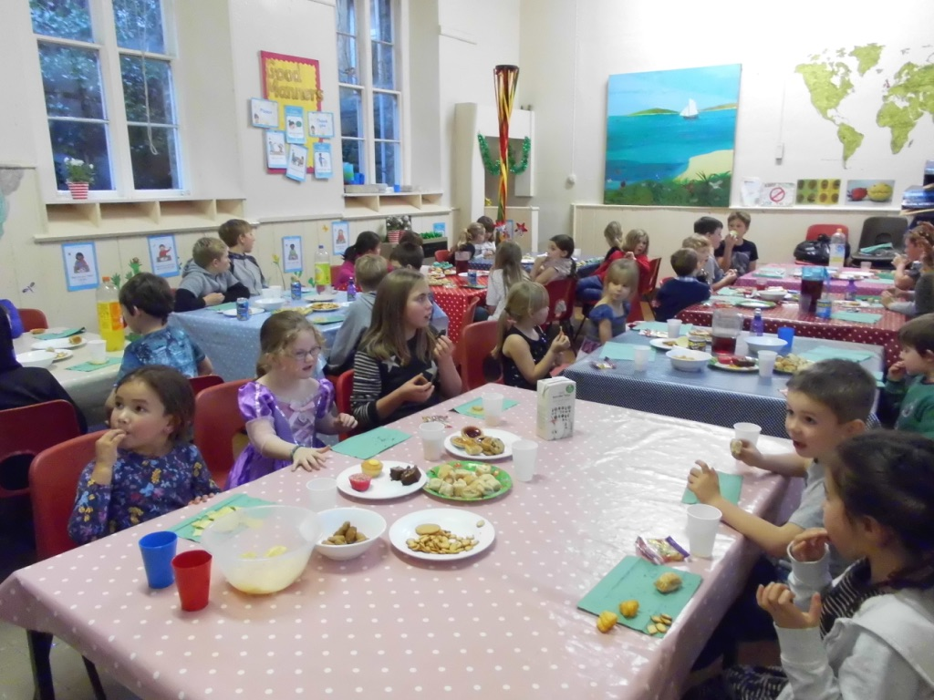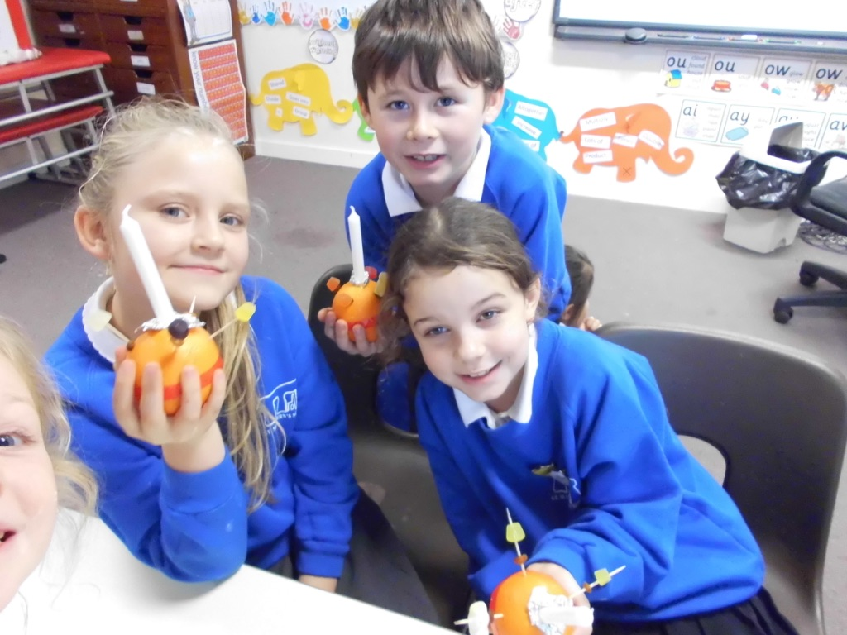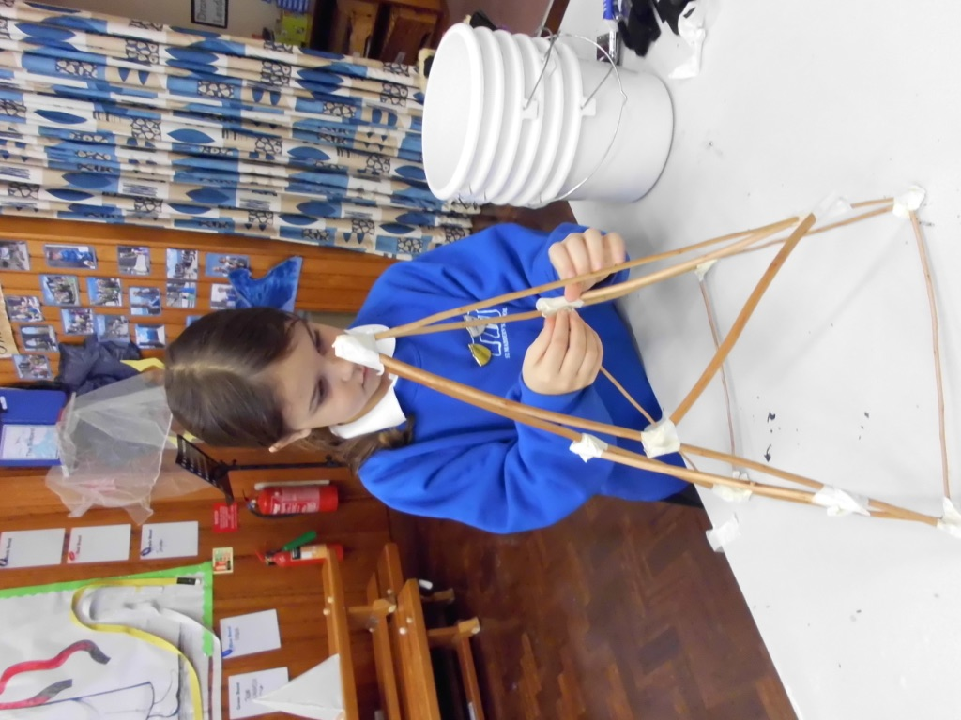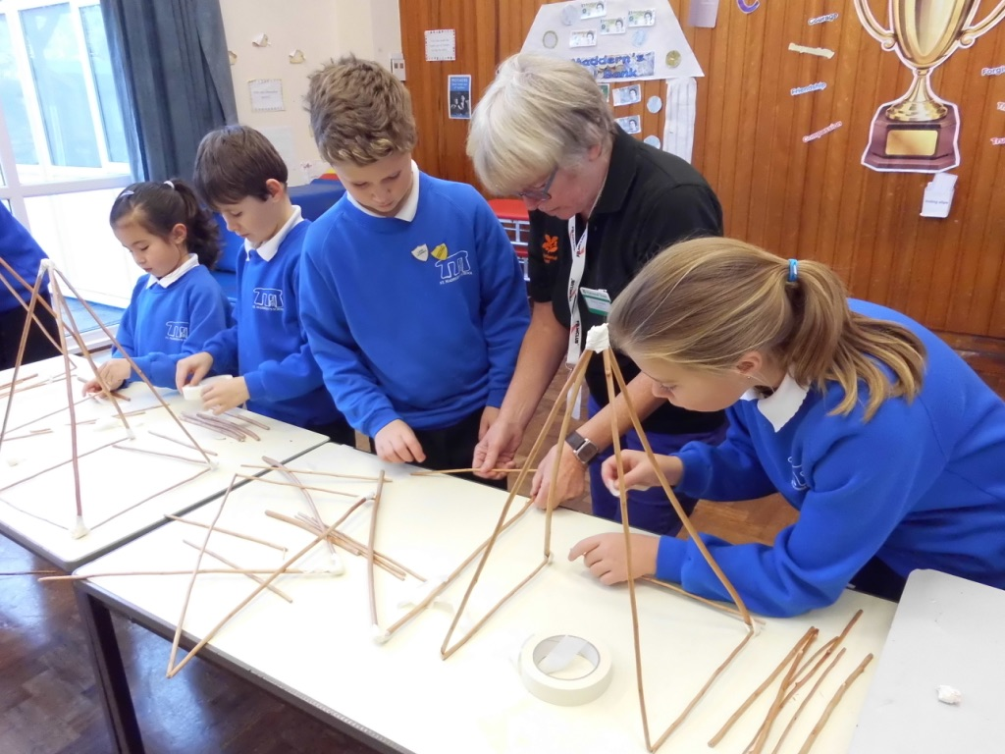We had a morning filled with fun, and getting messy making our lanterns. These were displayed in Trengwainton Gardens for everyone to see!

The fun did not stop there, before we broke up for the holidays we had a Christmas party. We played lots of games, and had party food. Santa even came to visit!

Christingle making for the service at the church.

everyone to see!