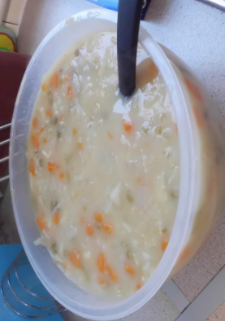
Class 2 - October News 2016

Class 2 have been finding out about different Tudor foods. We found a recipe for Tudor pottage. We enjoyed cooking this, and compared it to supermarket vegetable soup. The children thought it tasted disgusting and very bland.
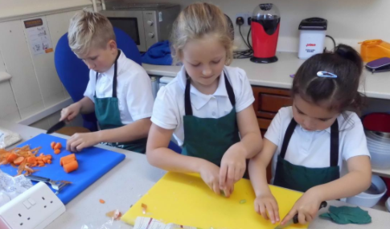

We have been researching about King Henry VIII. Writing a biography about his life, and a newspaper report on one of his six wives.
In art with Emma we drew portraits of King Henry. Some were especially chosen to be hung in our St.Maddern’s Gallery.

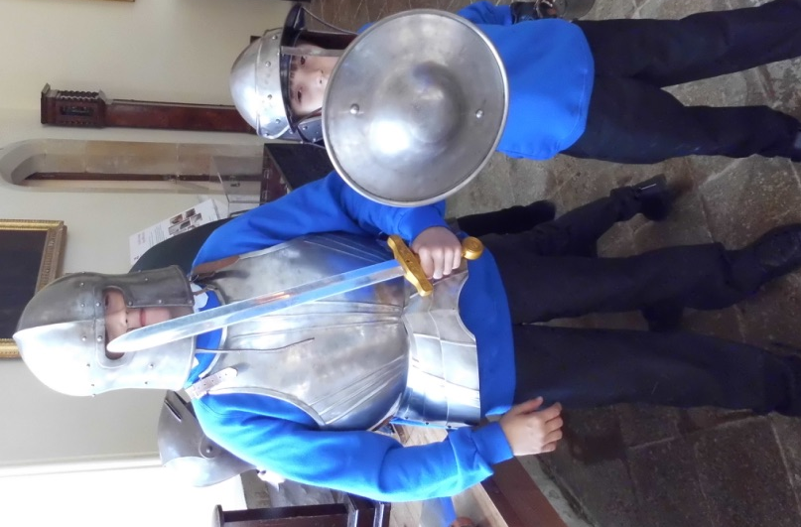
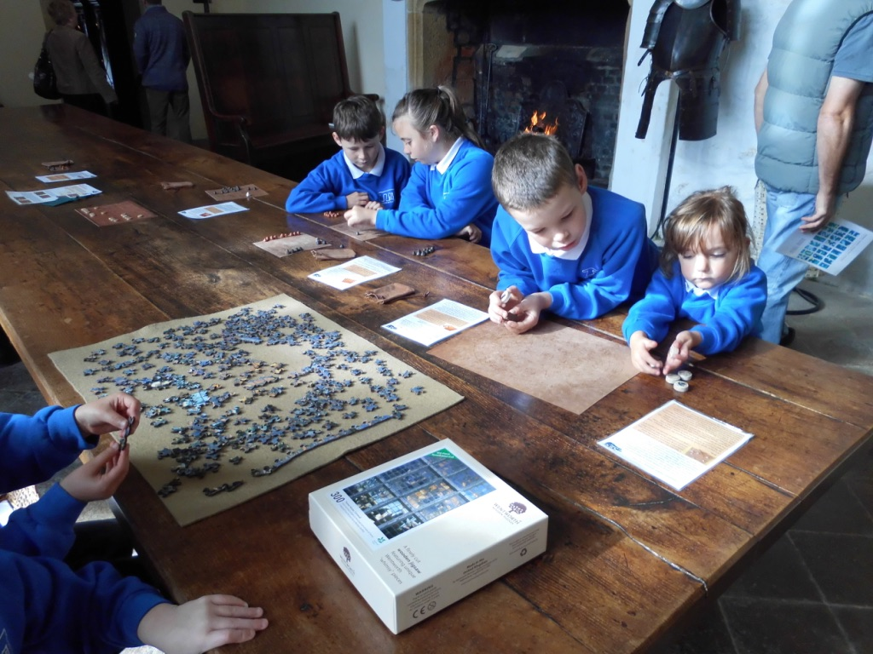
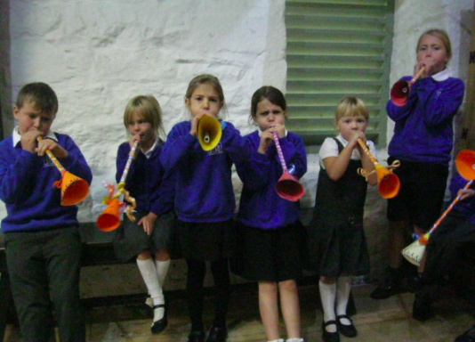
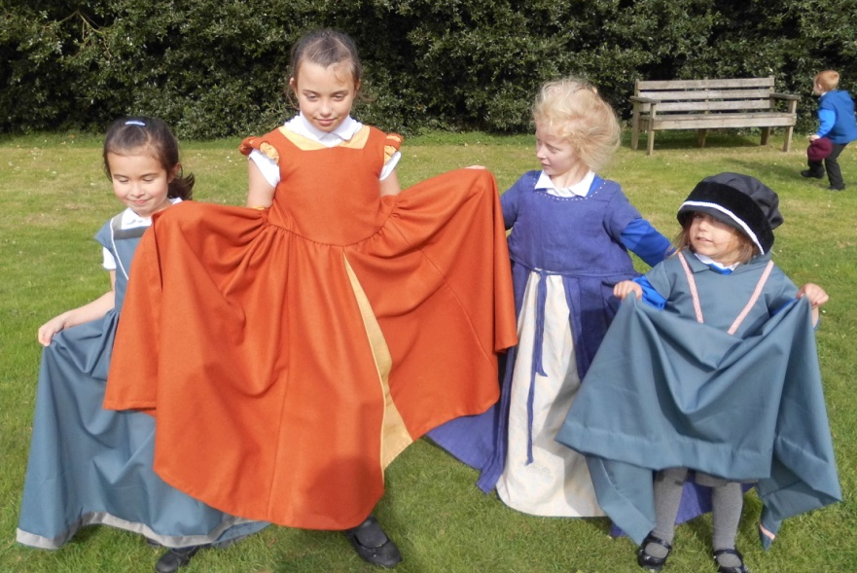
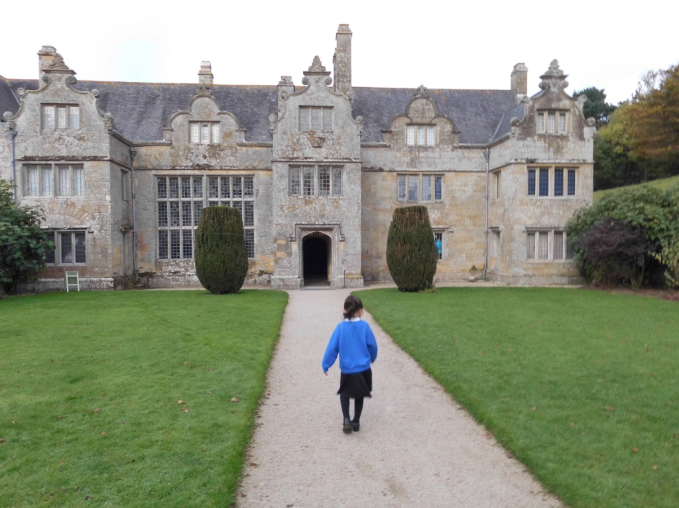
We visited Trerice Manor House to learn about its history during Tudor times. The children had a fun day, learning lots of interesting facts about Tudor times. We also got to dress up, explore the Tudor maze, play Tudor games and make a Tudor instrument.

