Inclusion Project Report
Summer 2014
St Maddern’s School and Nancealverne School
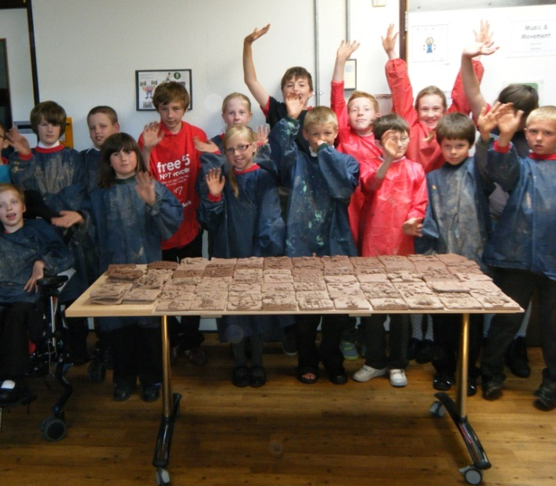

Introduction
Over the course of 10 weeks in the Summer term, pupils from Years 3-6 at St Maddern’s and Nancealverne got together for an inclusion project: at St Maddern’s for joint music sessions learning Cornish songs and at Nancealverne for pottery sessions to create a plaque for St Maddern’s. The project was incredibly successful - all students enjoyed the experience, made new connections and learnt new skills. This is hopefully just the starting point of a long-term collaboration.

Desired Outcomes

- Mutuality - we wanted the project to offer something from both sides, to be mutually beneficial
- Social aspect - built in opportunities for social interaction as well as skill building. We felt that this was really important for students.
- Learn new skills
- Building bridges/breaking down barriers – promoting greater understanding of the nature of disability
- Raising aspiration - a culture of achievement on both sides – showing others how much we can do as well as giving something to work towards
- A performance/celebration - something to work towards to celebrate the work done and the connections made
- Beginning of a long term, ongoing relationship between the schools
What were the factors that made the project work so well?

- Enjoyable, motivating activities
- The project was well planned and there were clear goals/outcomes
- Local, so not far to travel
- Even mix of pupils from both schools
- CPD opportunities for all staff members (from new skills in music/pottery to insight into different settings/behaviour management, etc.)
- Well-staffed on both sides
- Social aspect - mixing at playtime made a big difference to pupils at Nancealverne
- a commitment to and enthusiasm for the project on both sides
- opportunities to extend the project into other areas (e.g. sports inclusion/leader role for one of Nancealverne’s pupils)

Planning

One of the reasons the project was so successful was the level of joint planning that kick-started it. All sessions were timetabled in advance to fit around school commitments and gave a clear framework to the project. Staff on both sides were committed to making the project a success and put in a lot of effort to ensure it worked well.

Challenges

The main challenges were in transporting pupils and finding space (particularly at Nancealverne), but these were overcome without issue as both parties had a desire for the project to succeed.

Outcomes and achievements

The project was extremely successful. Aims were realised and there were additional spin-off benefits, specifically, extra inclusion sessions for a Nancealverne pupil (and the opportunity to be a sports leader).
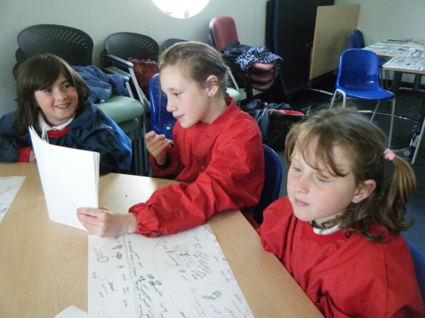
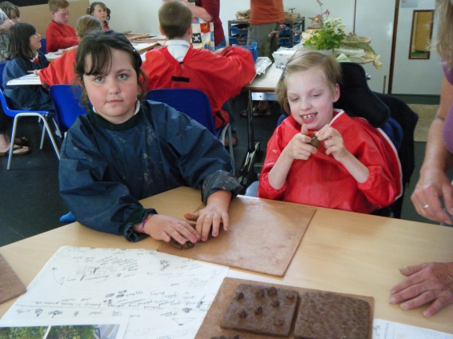

St Madderns’ comments:

- wonderful opportunity for both parties to learn and develop new friendships between the schools
- fantastic for our children to break down misconceptions they may have had about people with disabilities
- children learnt some signing to accompany songs
- enjoyed having Nancealverne students and staff as guests for celebration
- pupils were able to work with a pottery expert, resulting in good quality of work - proud of the clay mural produced
- pupils were able to use specialised equipment - e.g. the potter’s wheel
- link between school is something we would like to develop further
- pupil evaluations positive - enjoyable and a good learning experience.
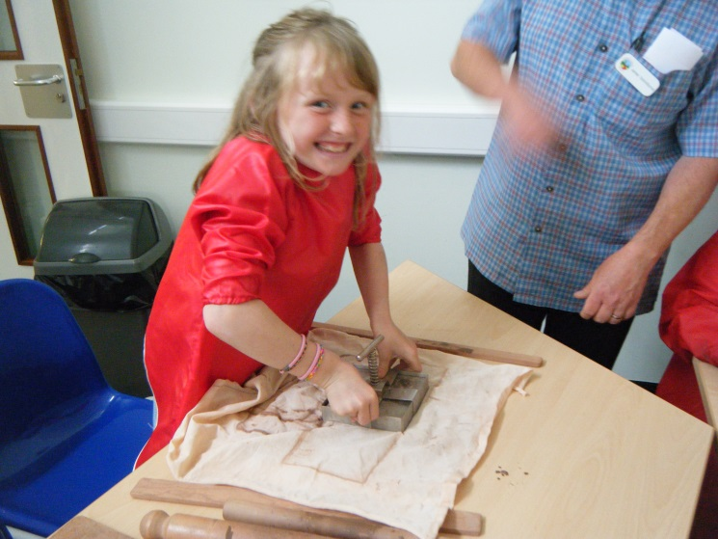

Nancealverne comments:

- fantastic opportunity for our children to develop new friendships and learn new skills
- linking with a small school was a real positive - it wasn’t such a big leap for our pupils, especially at playtime
- linking with the same group over a long period of time enabled connections to be made more easily
- social inclusion was a highlight for us - enabled our children to see and join in with cooperative play and gave us a great role model for play skills - in particular giving pointers for our children on how to talk about play and how to join in/initiate
- really impressed with the music specialist - all sessions were well planned and very inclusive. Signing aspect enabled all children to participate
- enabled our pupils to show off their skills - pottery/music are both areas in which they feel confident and are able to shine
- good mutual cpd opportunities - useful to go into a different setting, see how others do things
- spin-off inclusion for one of our pupils was really successful - really increased his self esteem to be able to work with mainstream pupils and do so sports leader work
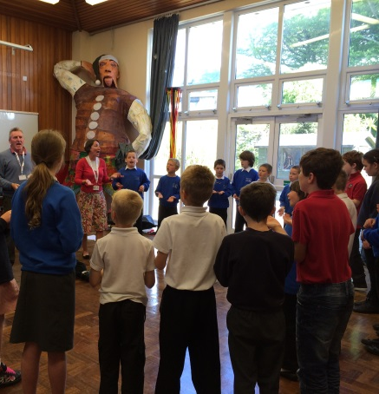
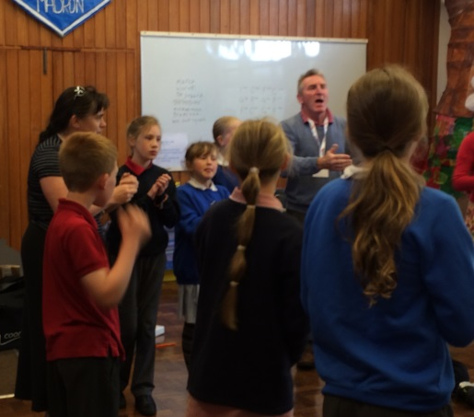

Anything we could make better for next time?

It would have been good to have a joint celebration at the end where both schools could have performed and the plaque been unveiled, but we ran out of time.

Summary

All parties thoroughly enjoyed the project, outcomes were met and exceeded and we, at Nancealverne, would love to continue to work with St Maddern’s. The school is a particularly good fit for us as it is small enough for our pupils not to feel overwhelmed, but large enough to give the wider peer group experience so important for improving social skills.

It is great to see the relationship continuing as St Maddern’s have invited us to their Christmas performance.

