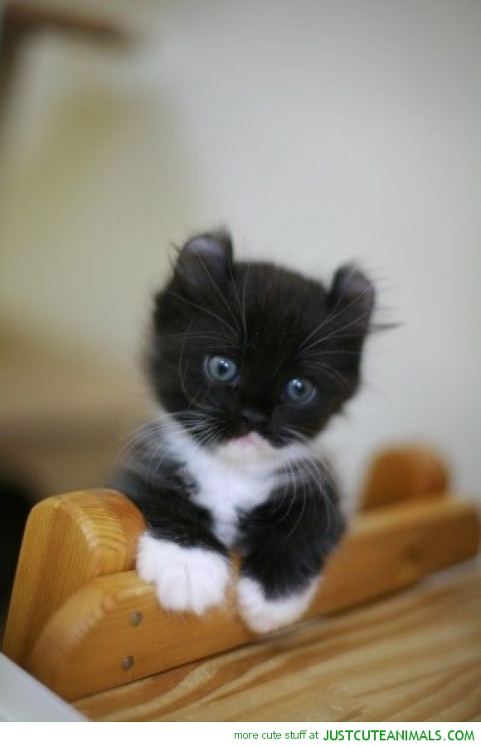
kittens scratch people.
kittens eat cat biscuits and drink milk .
kittens like to follow people around.
kittens run a lot.
kittens like to climb up on people.
kittens are so cute.
some kittens like to climb on the sofa.

