Class 2 - November News 2016

Class 2 have been learning about the different features of a Tudor house, what materials were used and how they were made. We had a go at applying our knowledge of nets and shape to carefully build our own Tudor houses. This took a lot of patience and perseverance!

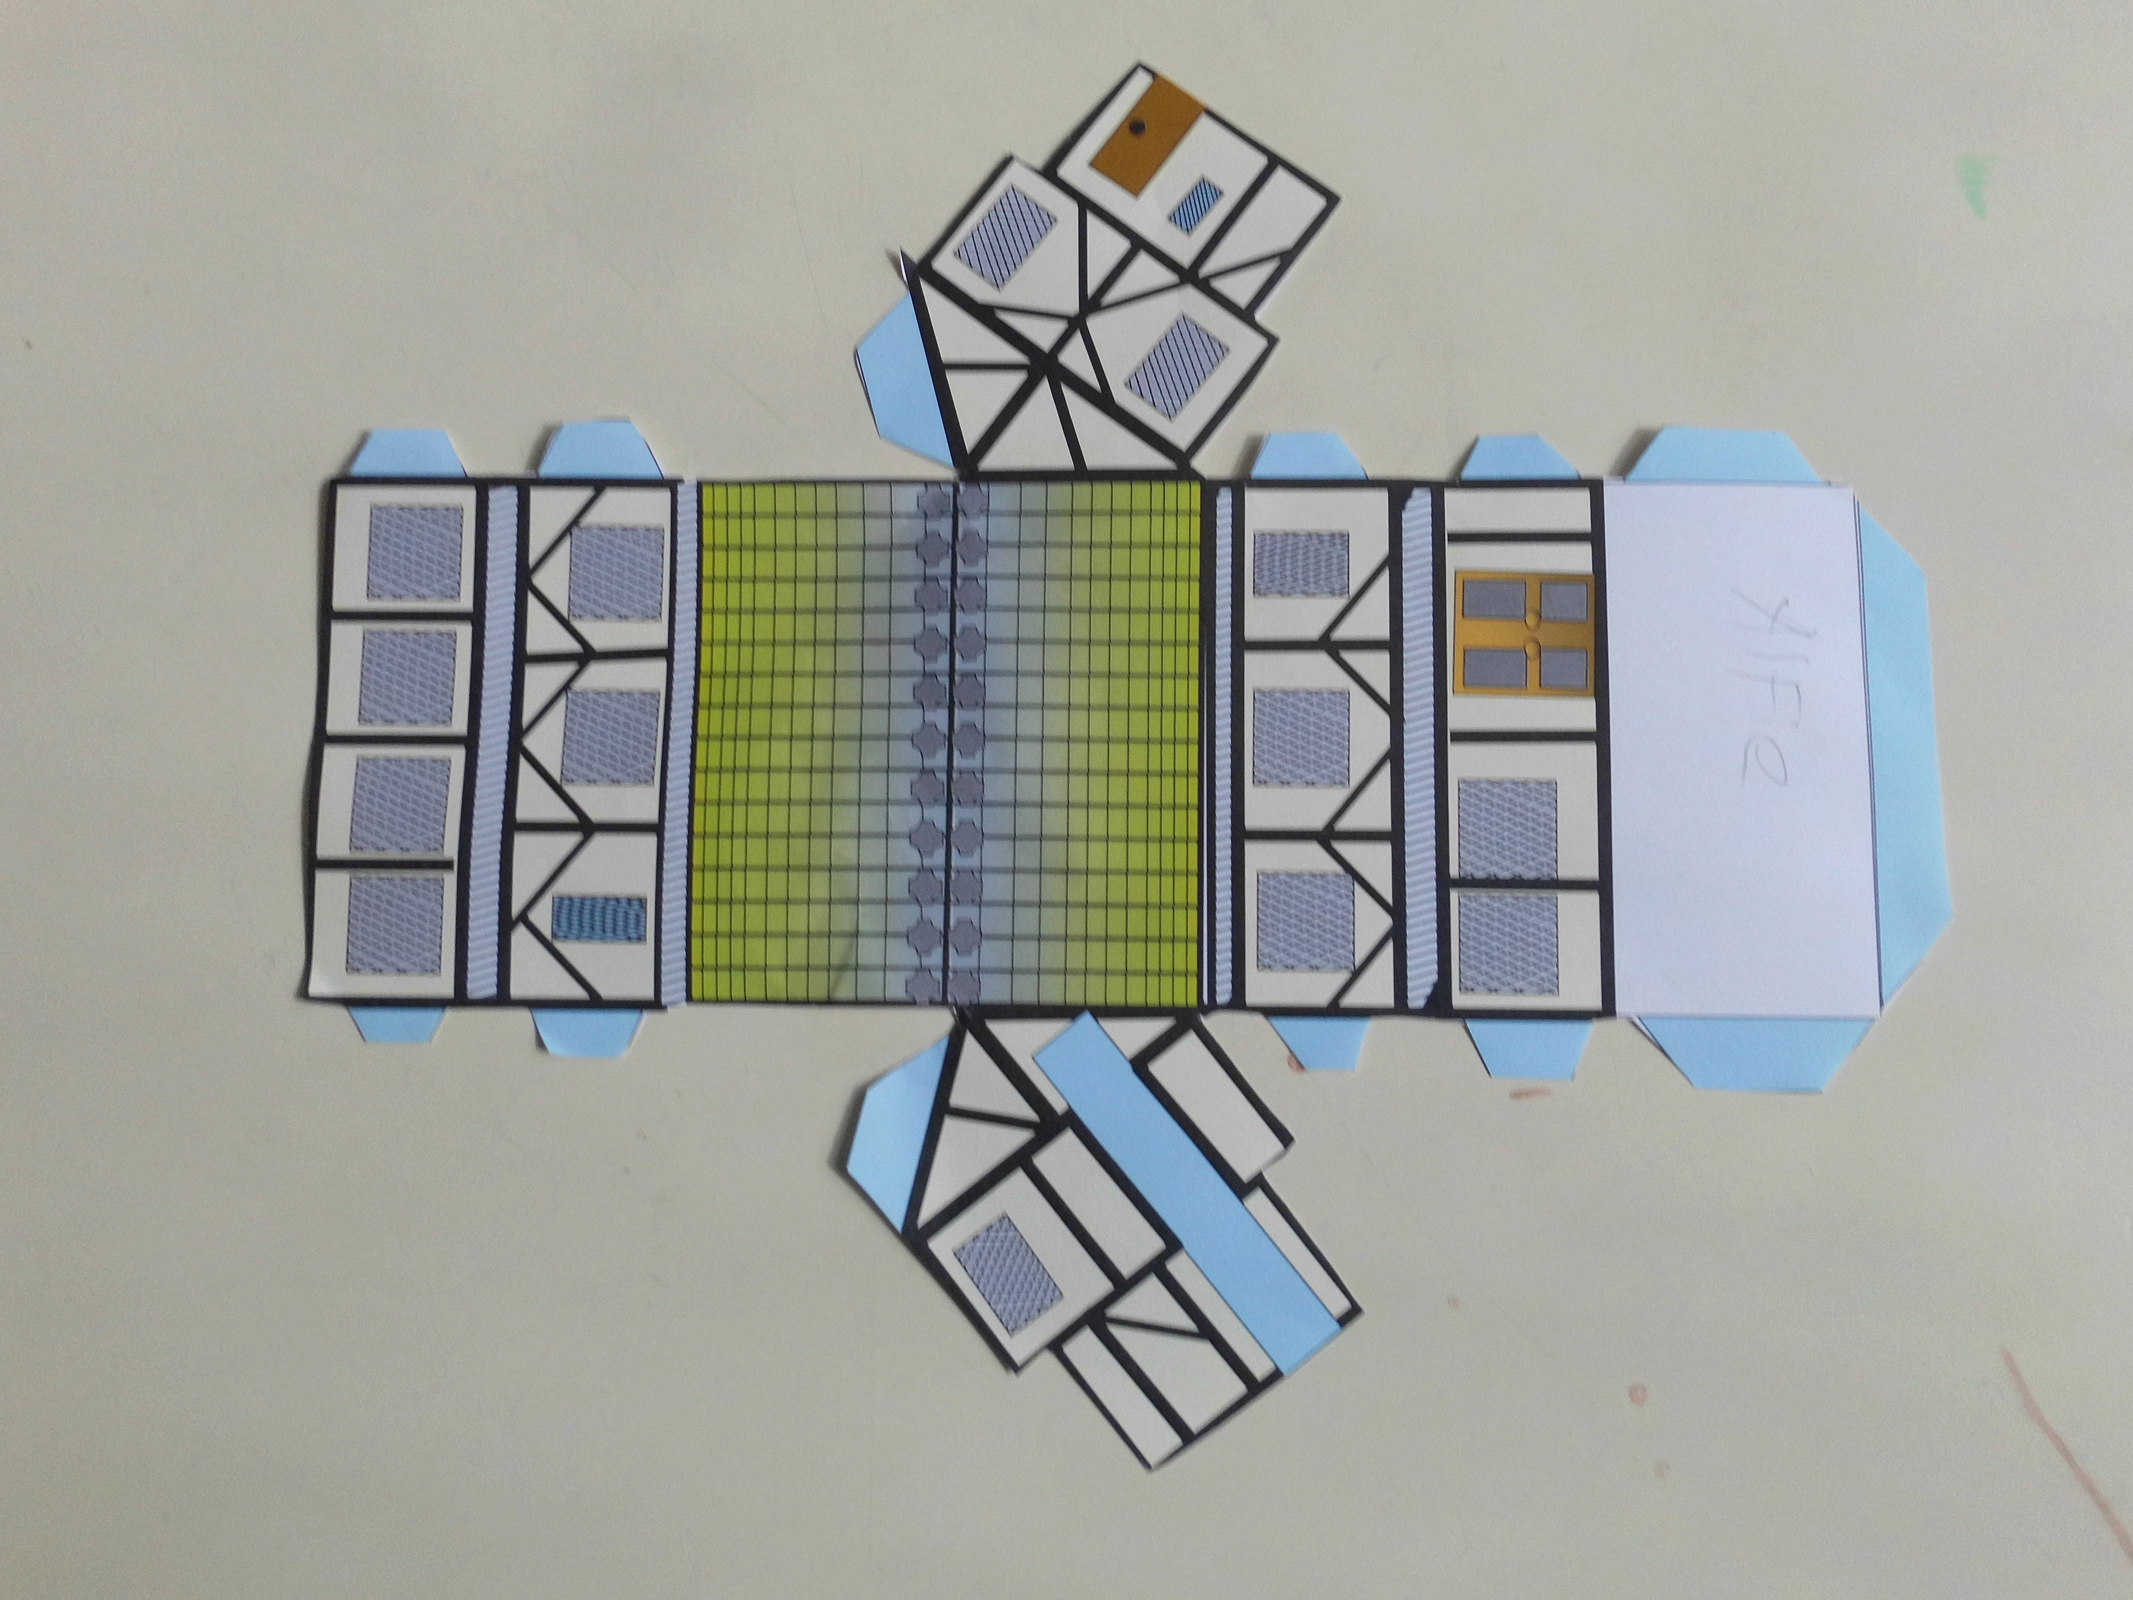

Class 2 got dressed up in ‘spots’ for Children in Need.
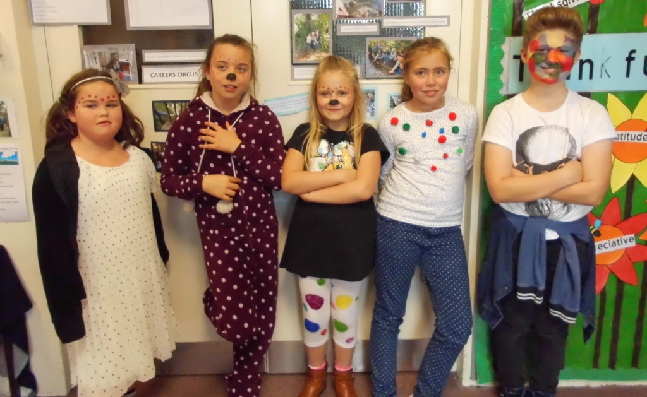

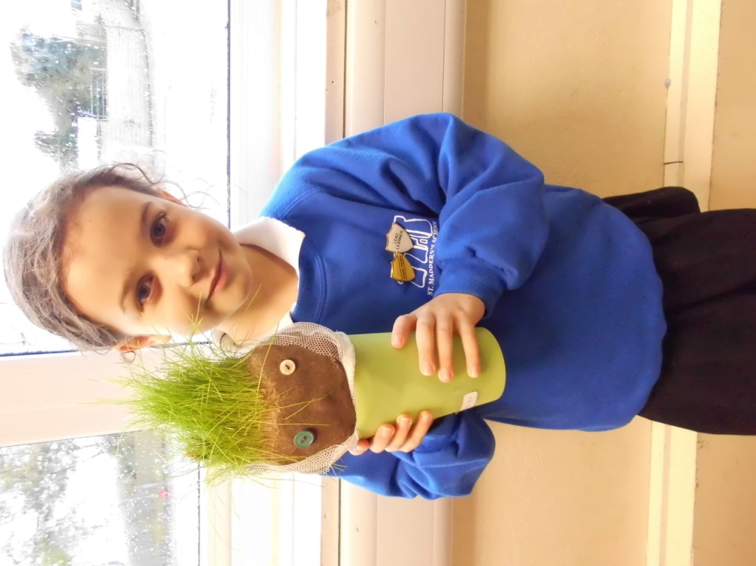

Class 2 planned, designed and made grass heads to be entered into a competition at Landithy Hall.
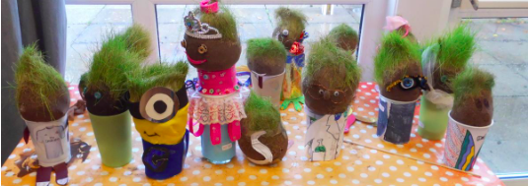

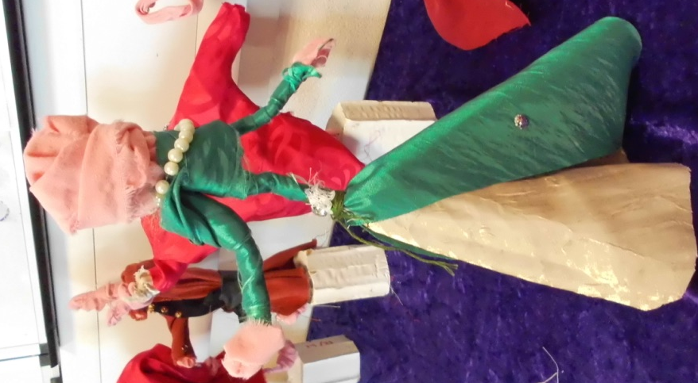
Class 2 have enjoyed working with Emma the artist on a Thursday. Creating these beautiful Tudor wire figures.

We went to Madron memorial garden to pay our respect on Remembrance Day.

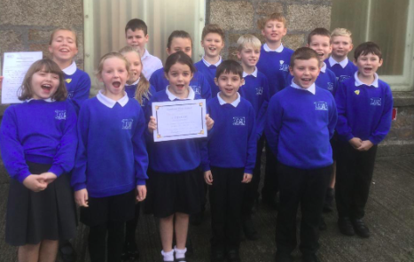
We competed at Camborne Music Festival with Ms.Judge. We enjoyed singing in front of a big audience. We received lots of positive feedback!

