Class 2 - September News 2016
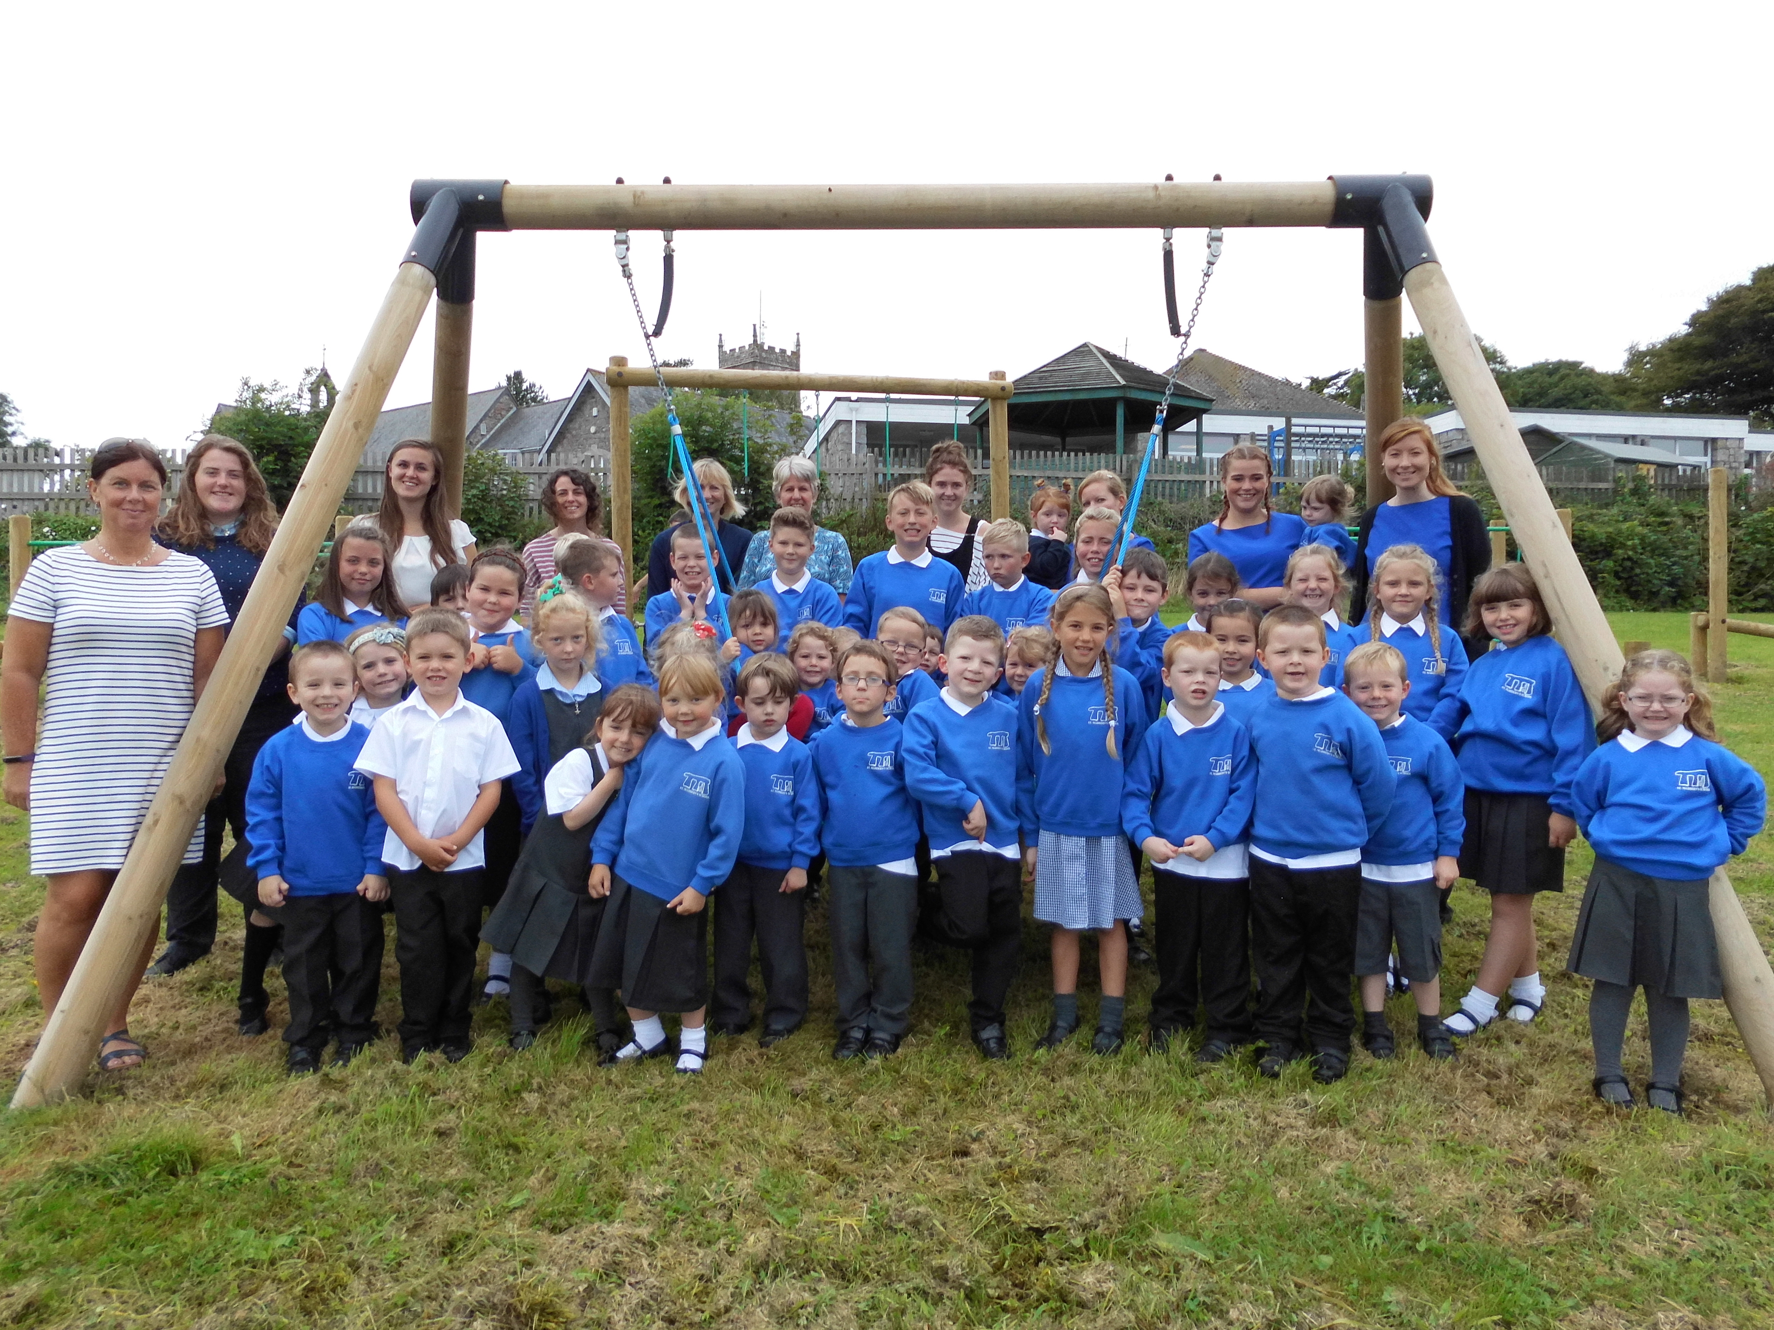

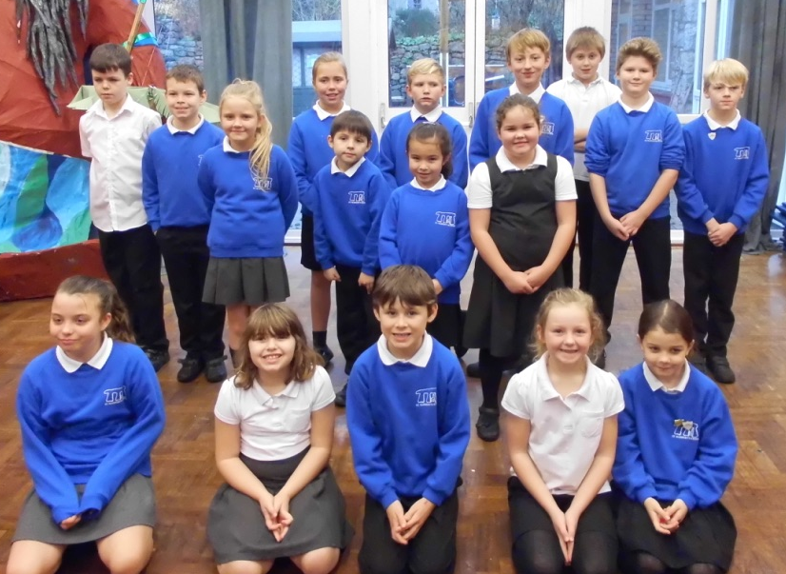
Class 2 are enjoying getting to know each other, and returning to school.

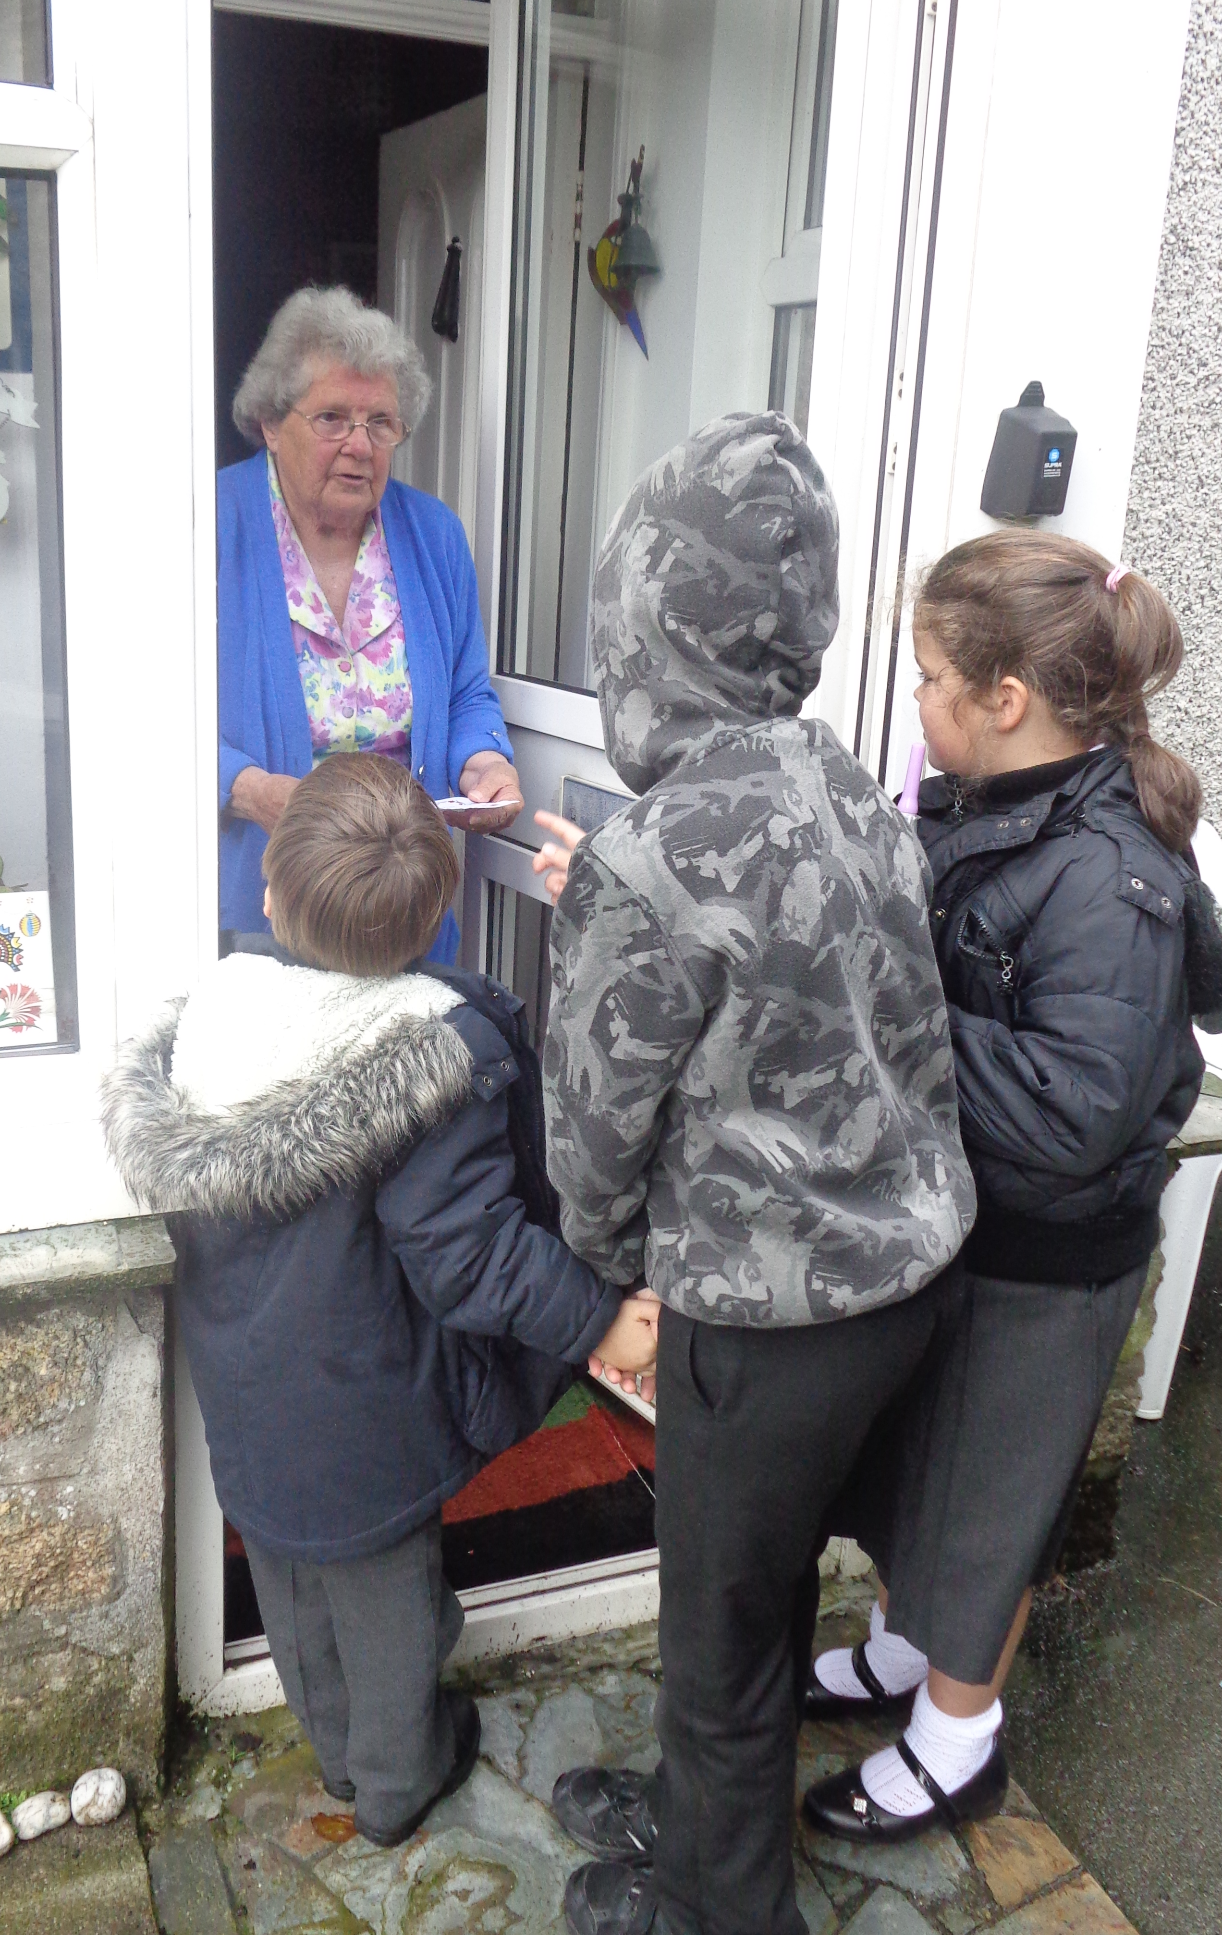
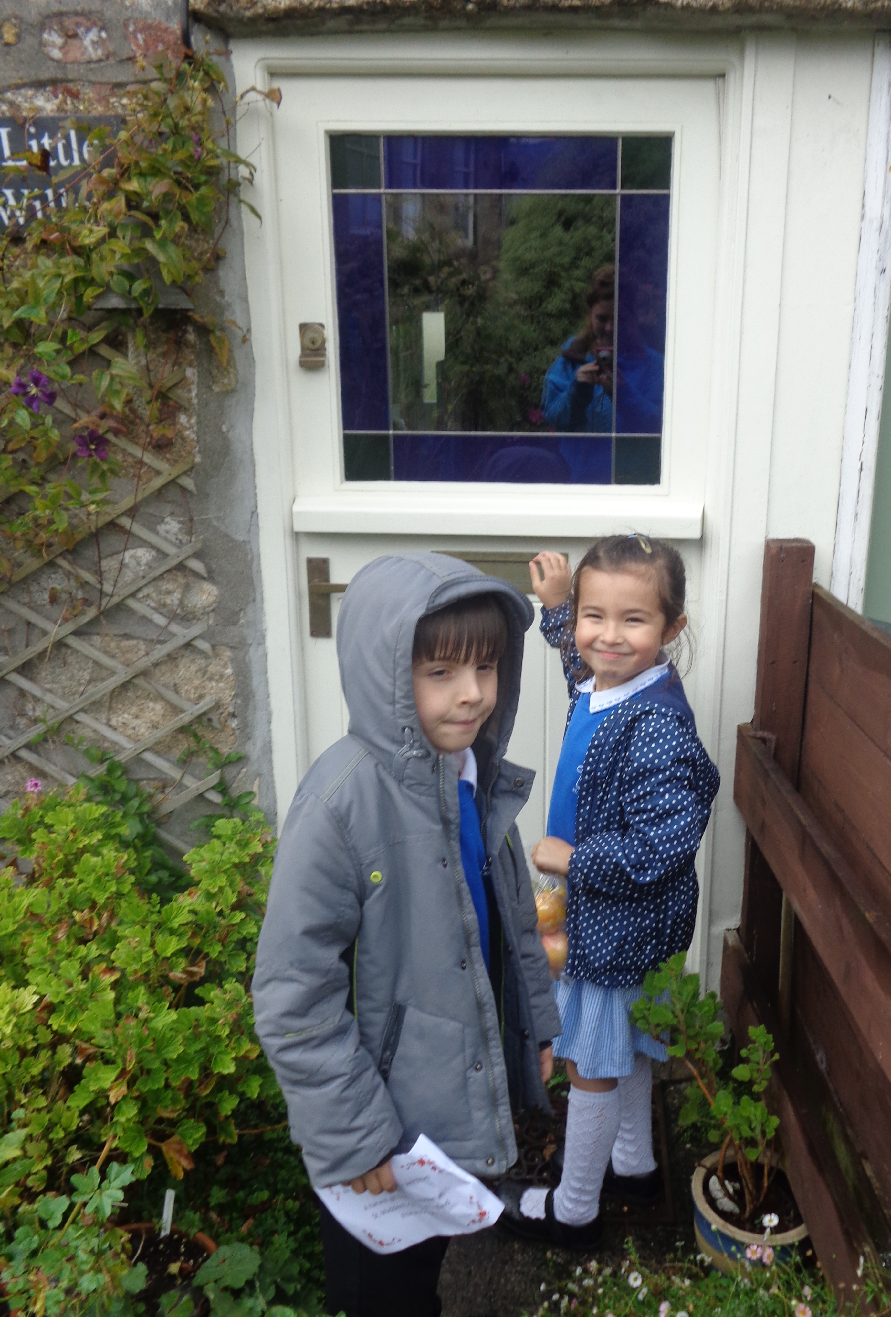
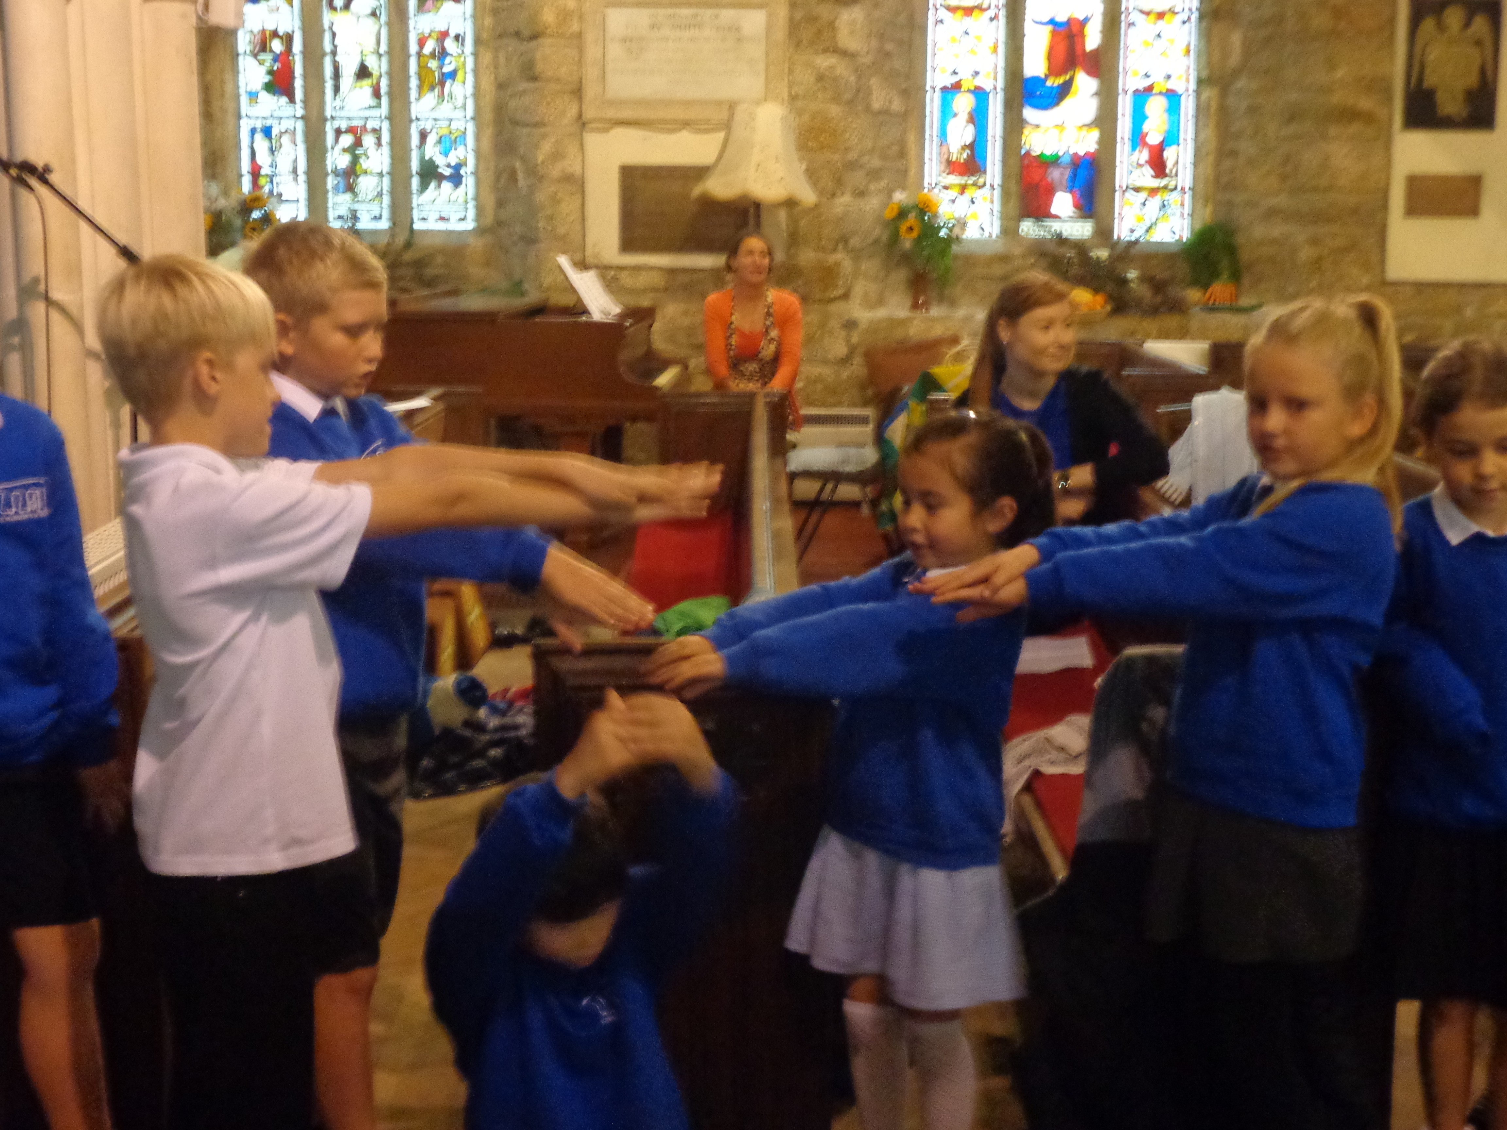
We celebrated Harvest through visiting the church and helping Tim with his service. We sang songs, preformed drama, read poems and prayers. Later on in the afternoon, we delivered harvest baskets around the village.

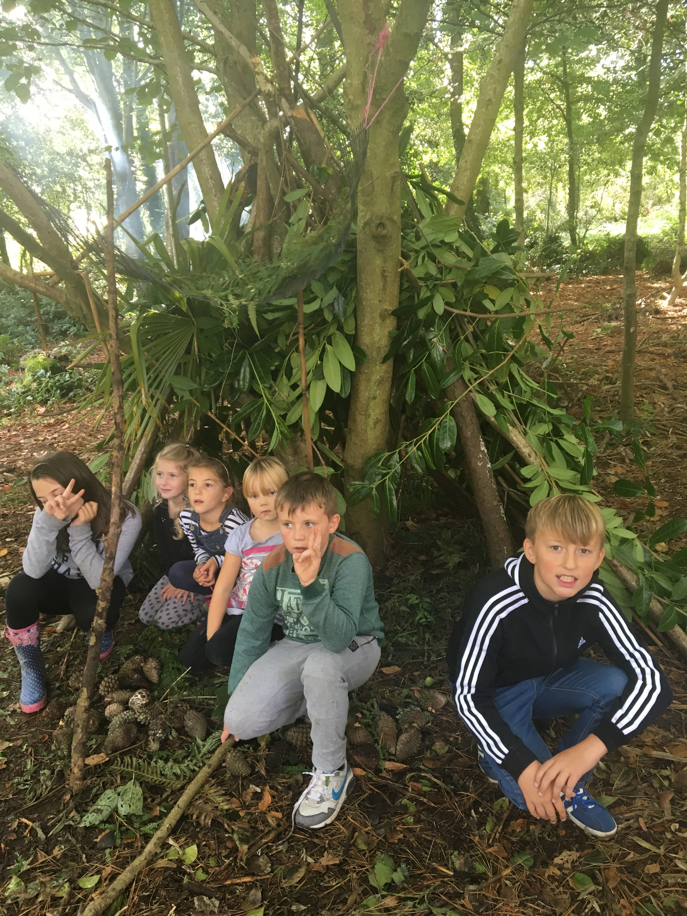
Class 2 loved our trip to Trengwainton Gardens. Where they worked as a team to build dens. They also got to roast marshmallows before they went home!
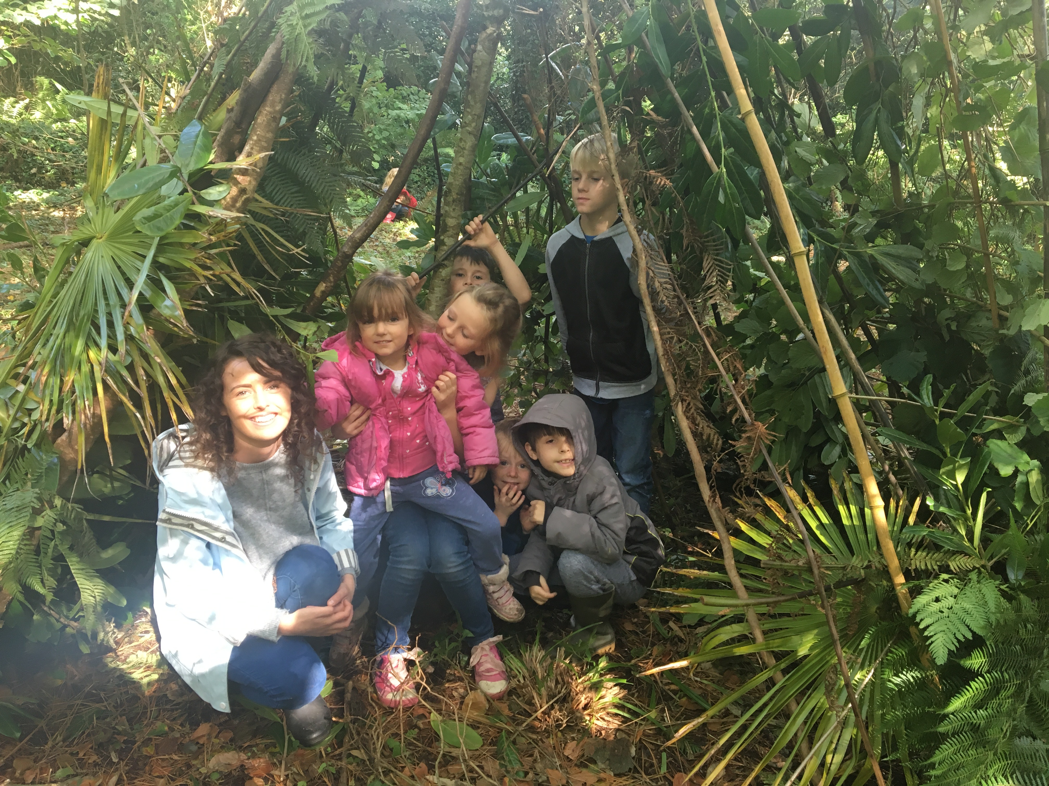

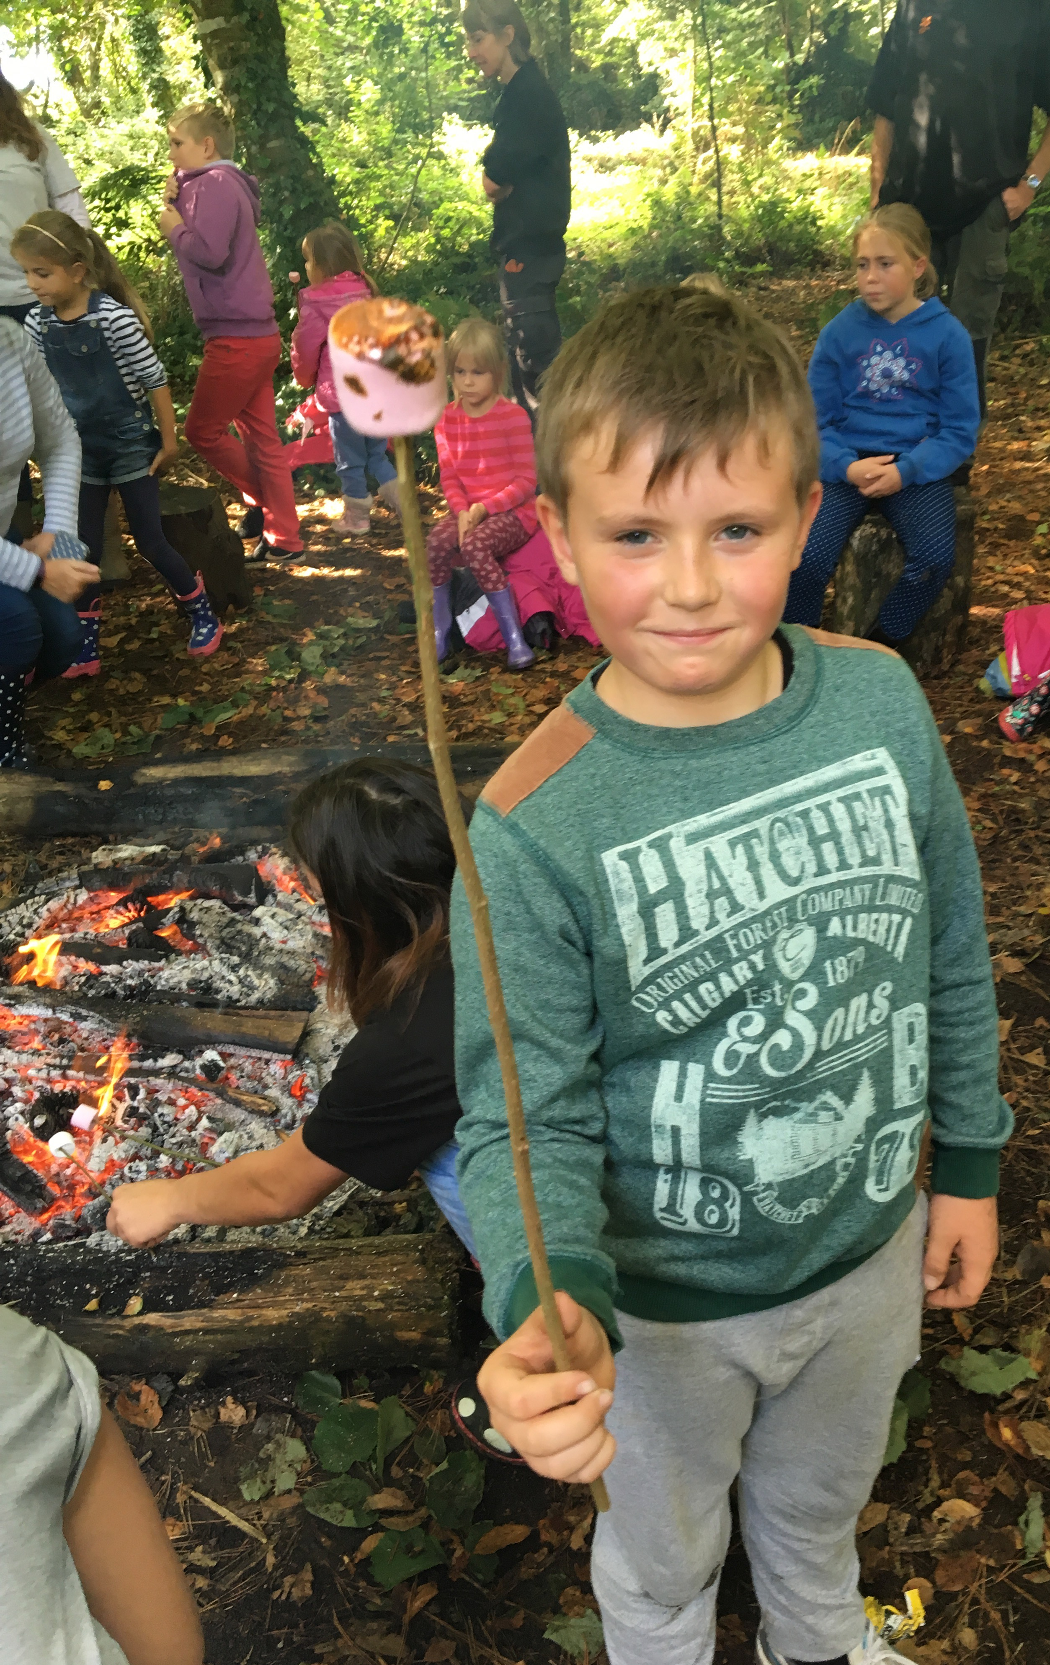
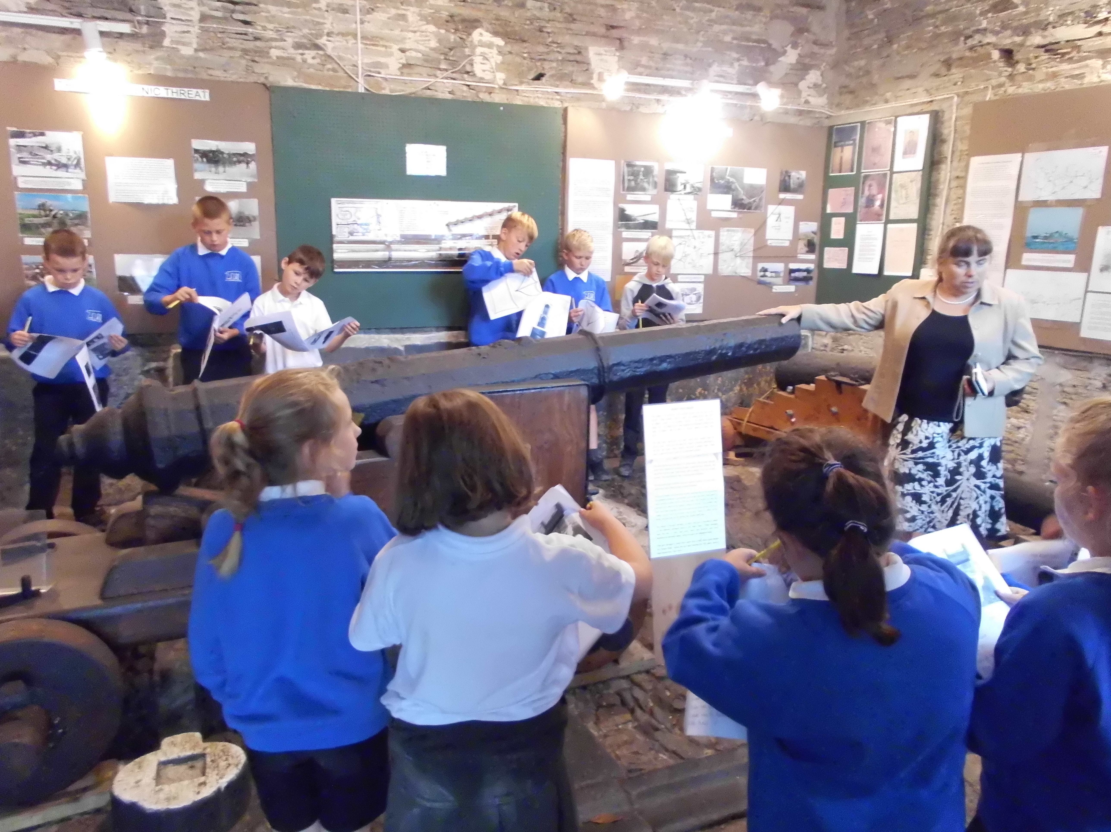
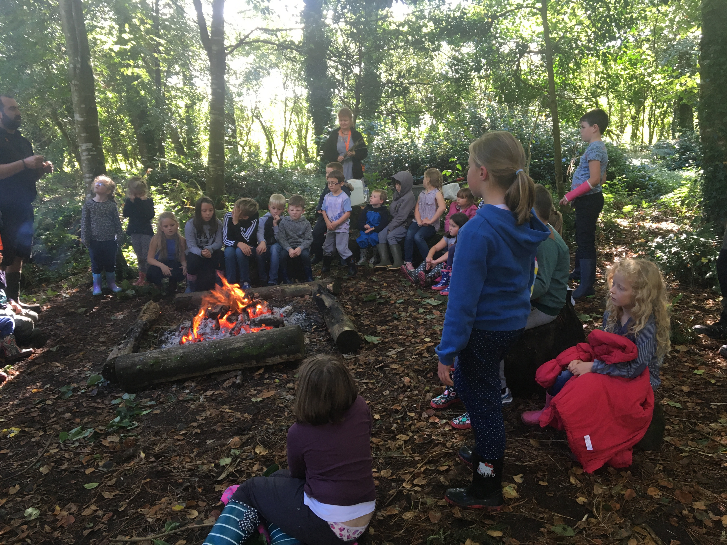
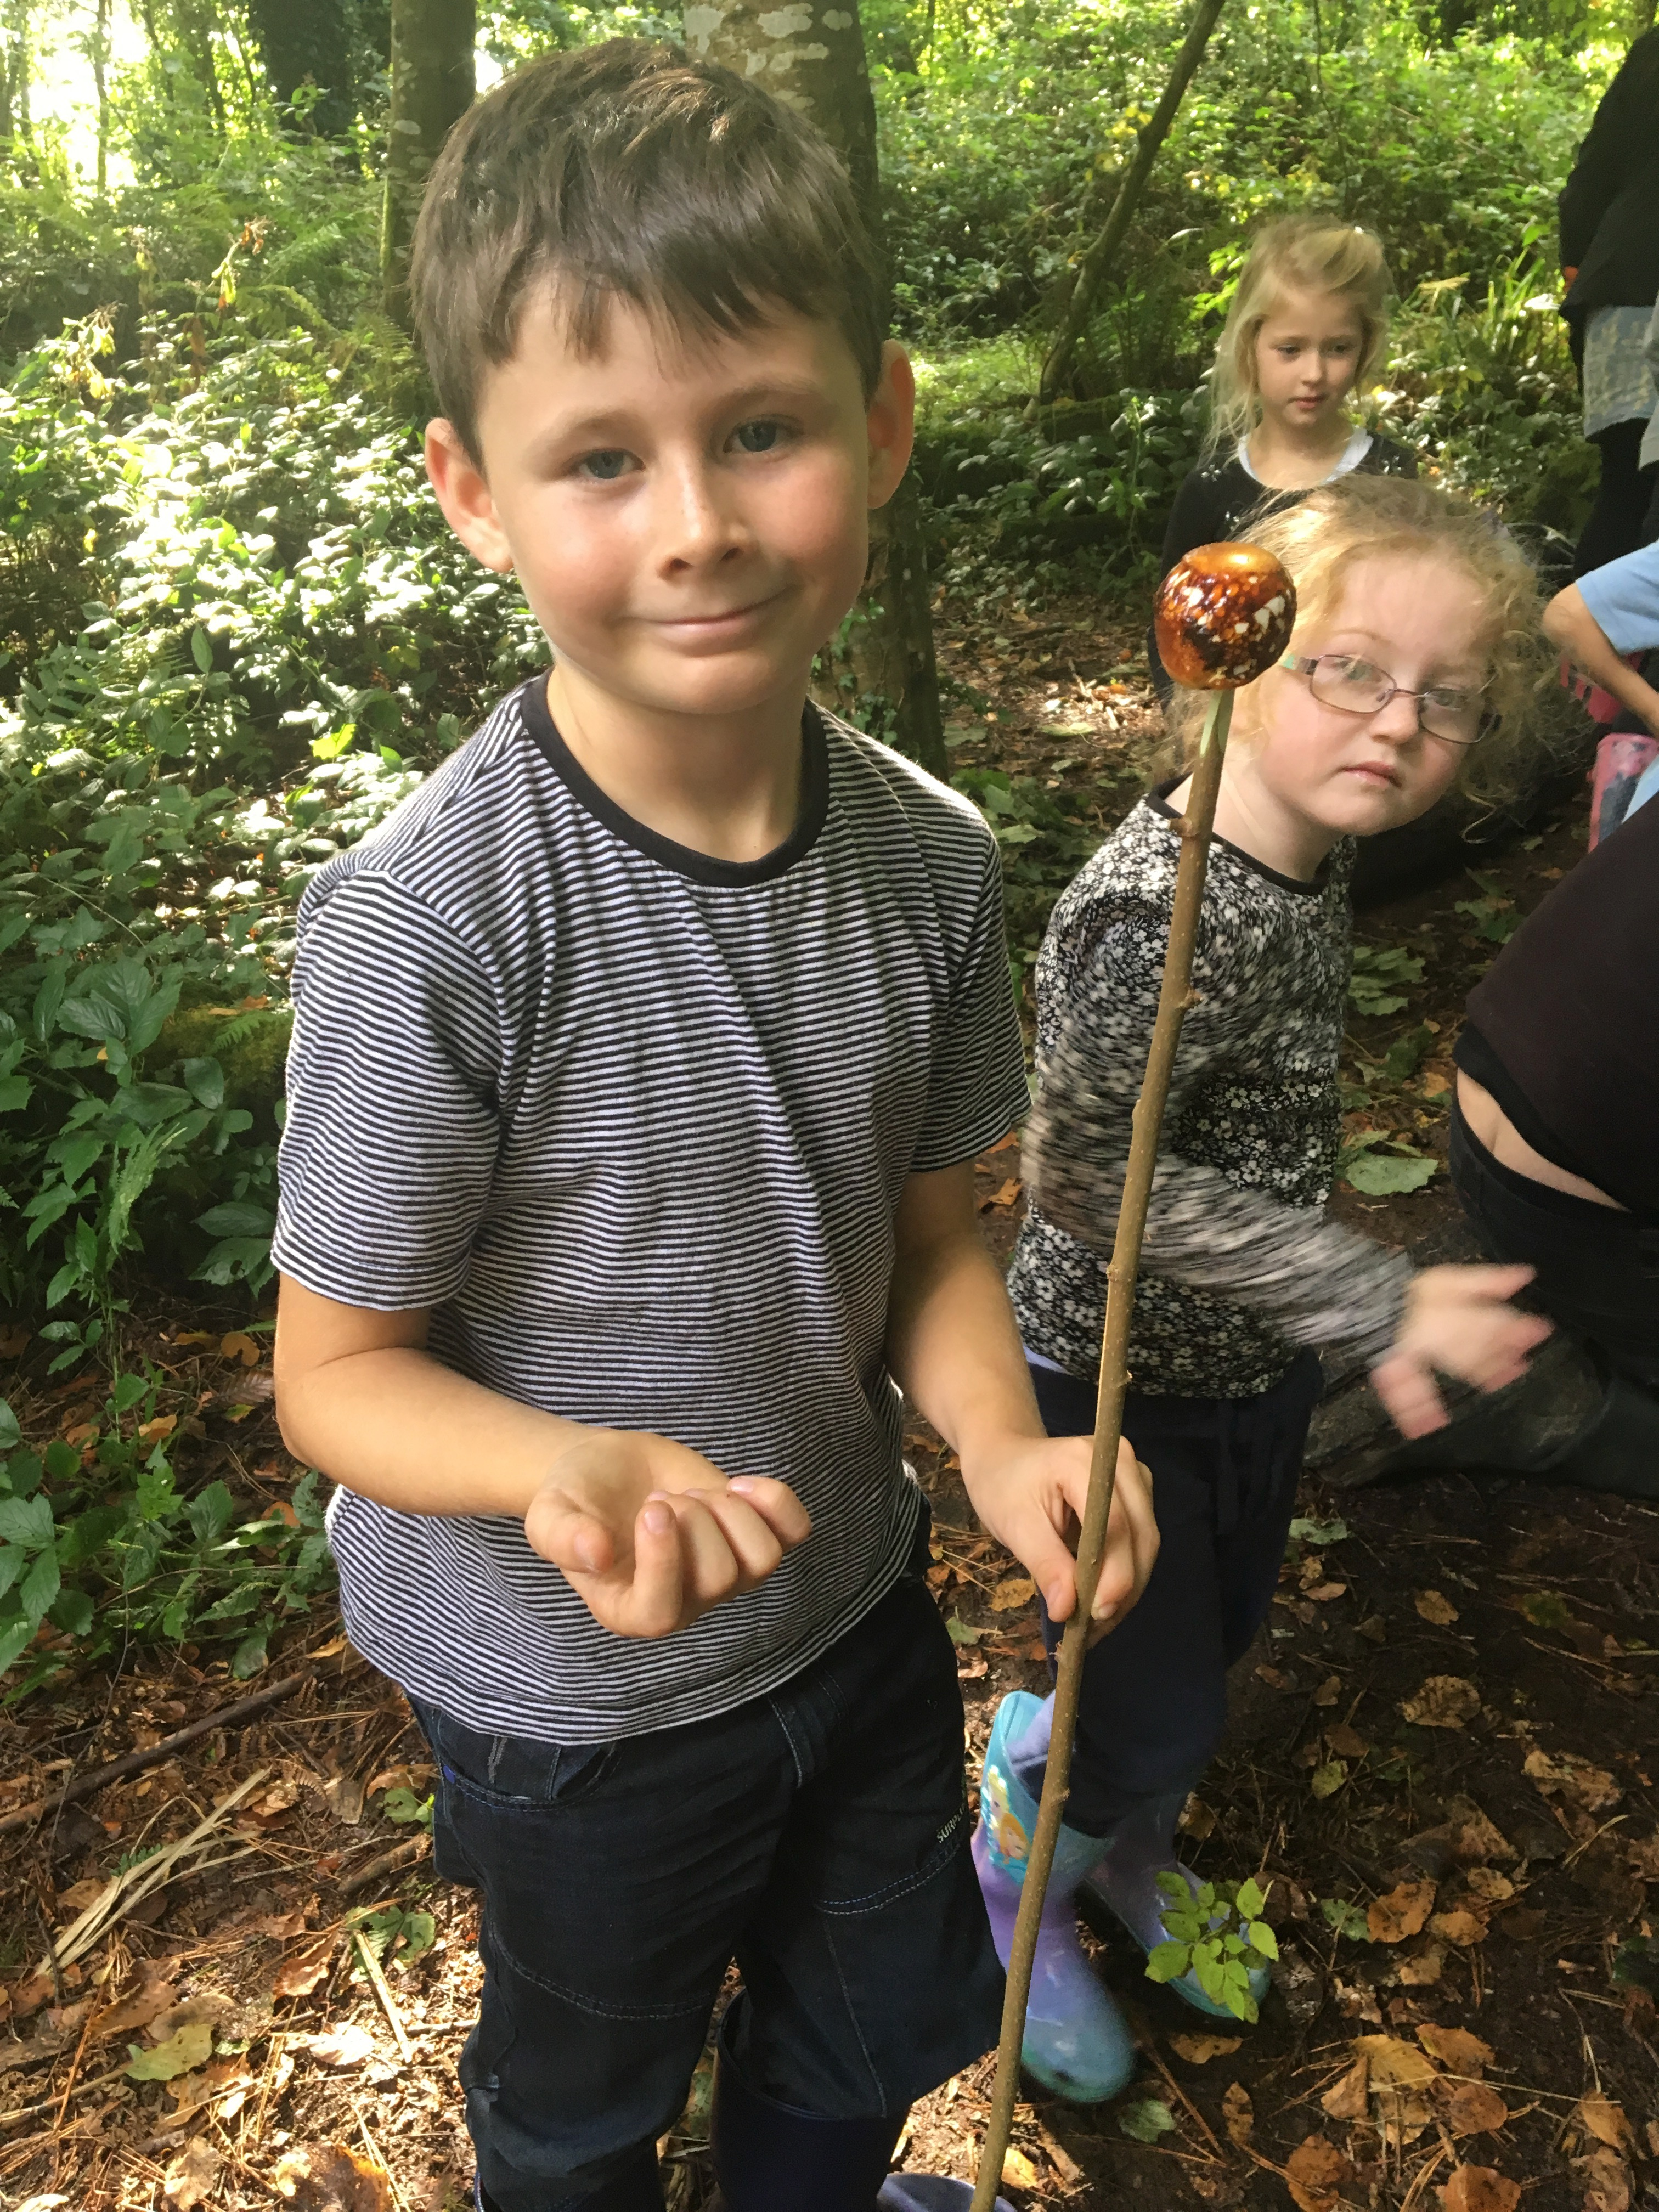

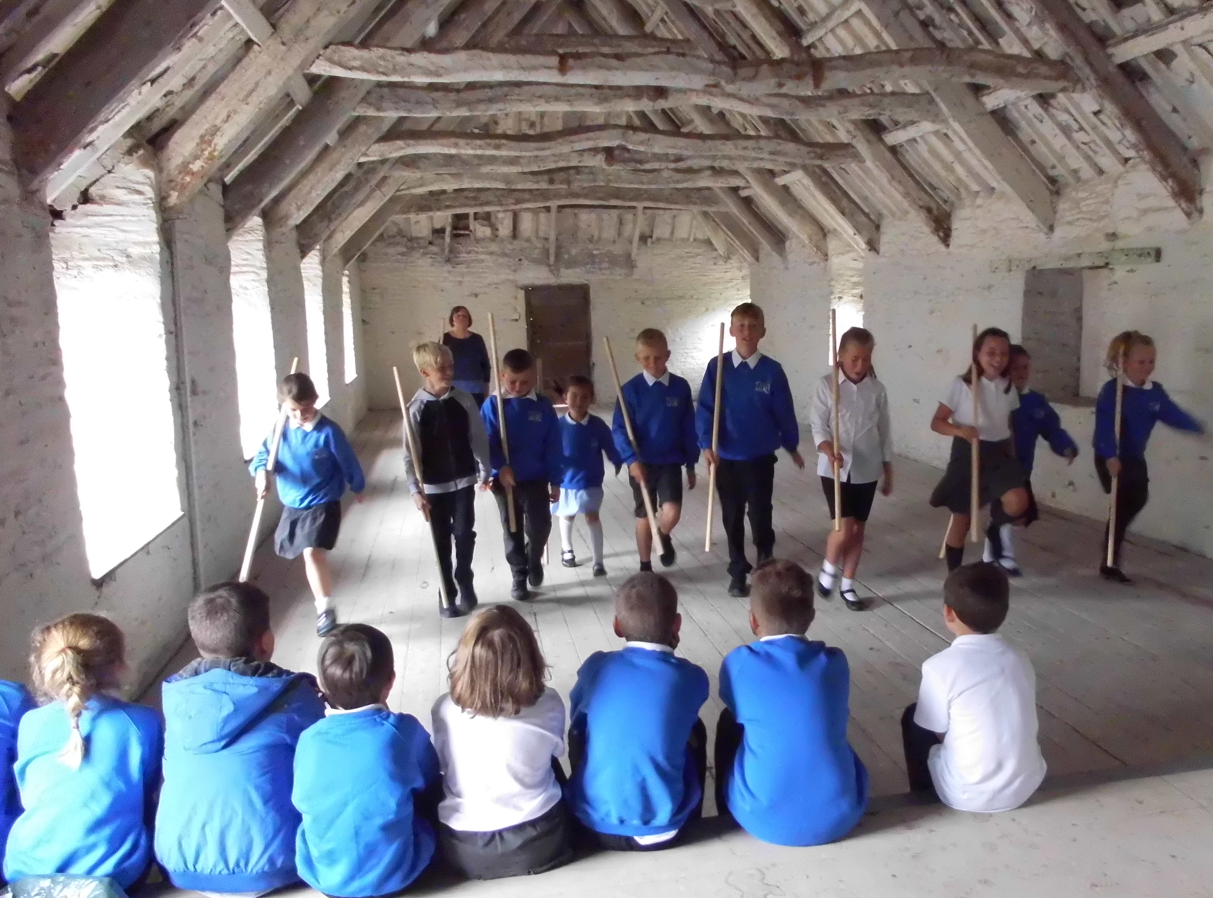
Class 2 enjoyed getting stuck into this terms topic of the Tudors by visiting Prideaux Place. Where we explored the Manor house and saw a cannon. We later became pikeman, made nosegays and learnt a Tudor dance.

